Creating a Data Warehouse in MSS (IDE for SQL Dev)

0.Setup 3

0.1 MSS GUI- Importing Sample Databases 3

1.Data Warehouse Foundations 11

1.1 MSS GUI- Data Warehouse Architecture 11

1.2 MSS GUI- Star Schema (Mapping of Fact & Dimension Tables) 12

1.3 Chapter Quiz 15

2.Create a Data Warehouse 16

2.1 MSS GUI- Creating a Database 16

2.2 MSS GUI- Creating fact and dimension schemas 17

2.3 MSS GUI- Creating dimension tables 18

2.4 MSS GUI- Creating a fact tables & adding PK-FK Relationships 19

2.5 MSS GUI- Creating an indexed view 21

2.6 Chapter Quiz 22

3.MSS GUI- Columnstore Indexes 23

3.1 MSS GUI- Creating a Column Store Index (To Improve Query Performance) 23

3.2 MSS GUI- Creating a Memory Optimized Column Store Table (To Improve Query Performance) 24

3.3 MSS GUI- Rebuilding Index (To Improve Query Performance) 25

3.4 Chapter Quiz 26

4.Implement an Azure SQL Datawarehouse (Runs on the Cloud) 27

4.1 Creating an Azure SQL Datawarehouse 27

4.2 Chapter Quiz 31

5.Extract, Transform and Load (ETL) 32

5.1 Chapter Quiz 32

6.Enforce Data Quality (Clean data after its loaded into data warehouse) 33

6.1 Installing the (SQL Server Data Quality Services) Plugin for the MSS GUI 33

6.2 Cleanse Data using the DQS Tool’s Default Knowledge Base 40

6.3 Cleanse Data using the DQS Tool’s Custom Knowledge Base 46

6.4 Chapter Quiz 57

7.Master Data Services (Clean data before its loaded into data warehouse) 58

7.1 Installing the (Master Data Services) Plugin for the MSS GUI 58

7.2 Installing IIS 64

7.2 Configure (Master Data Services) Plugin for the MSS GUI 67

7.3 Chapter Quiz 71

# 0.Setup

## 0.1 MSS GUI- Importing Sample Databases

1. Go to github and download the sample database

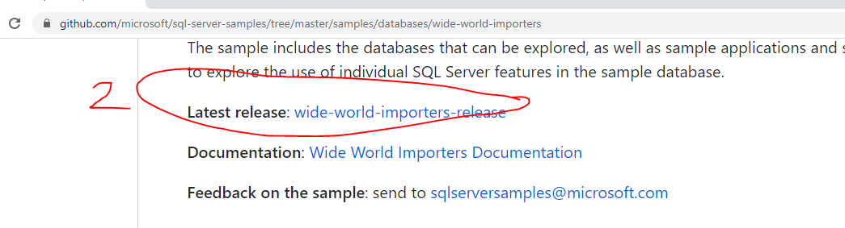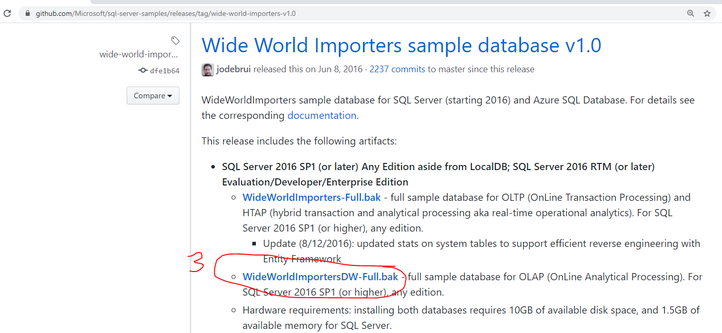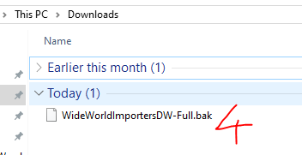

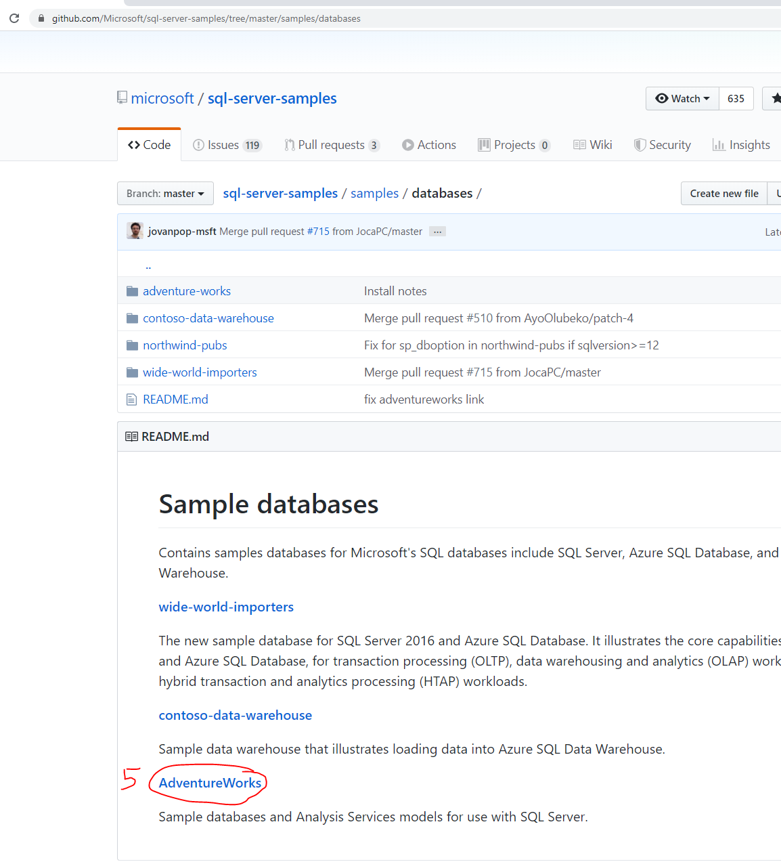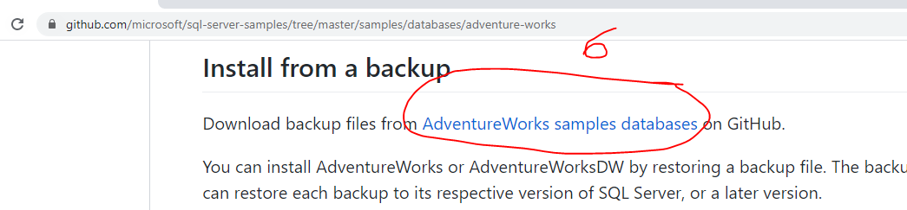

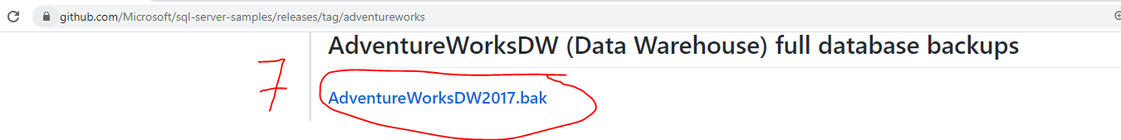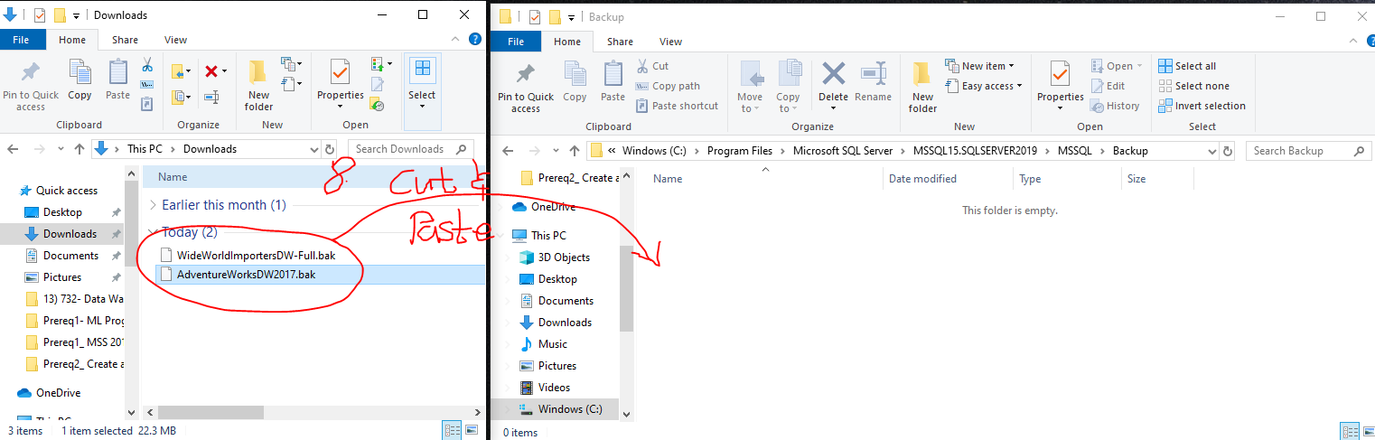

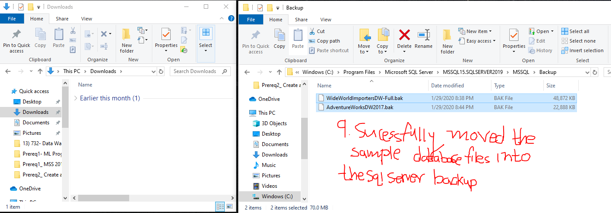

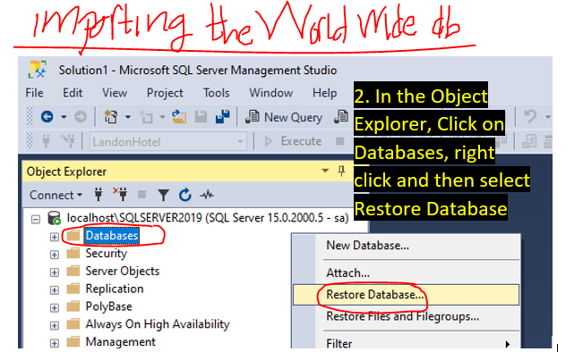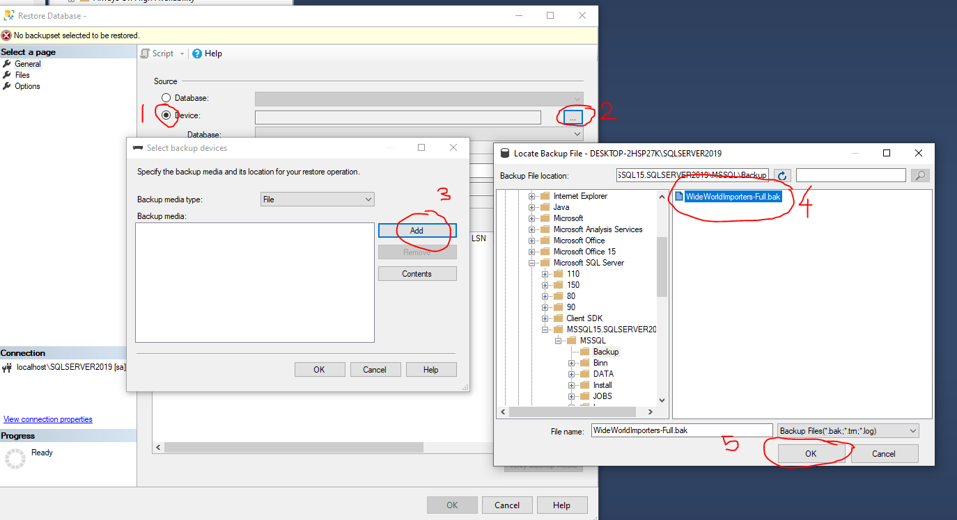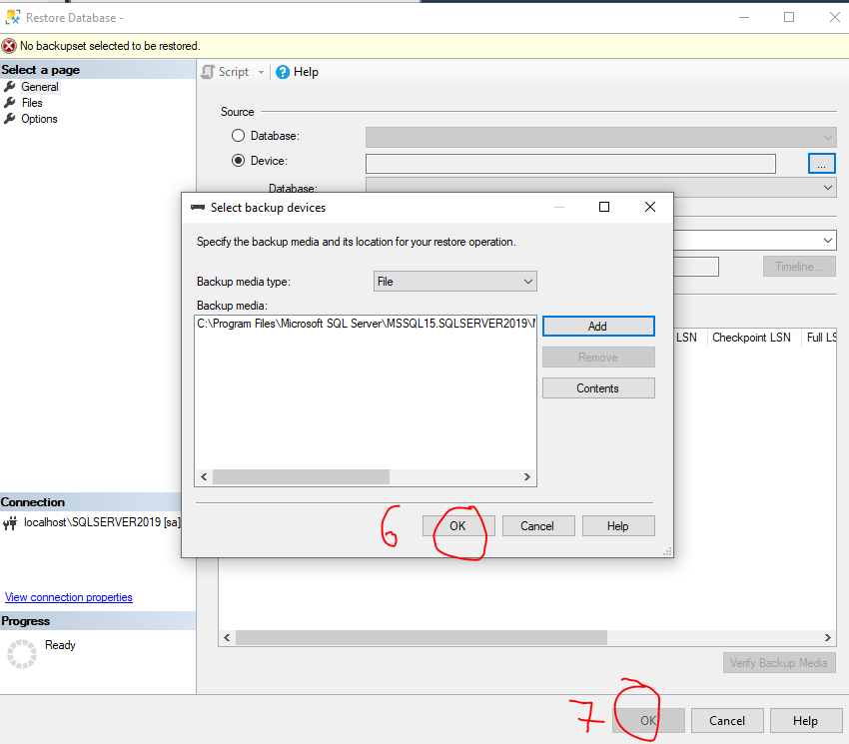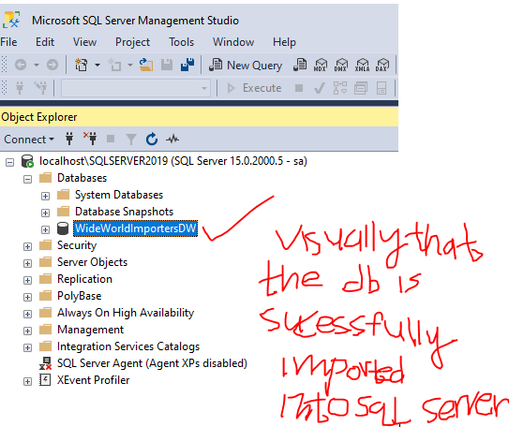

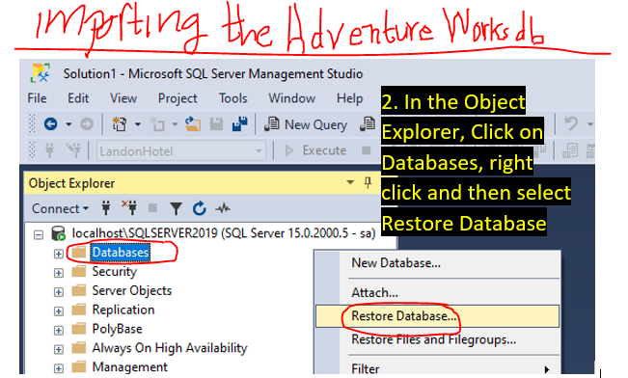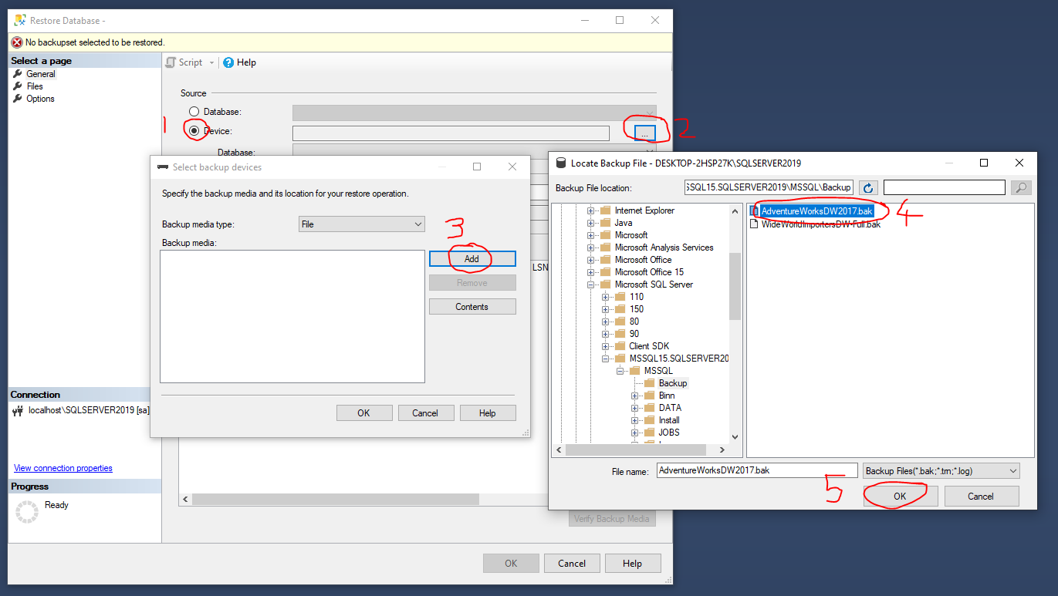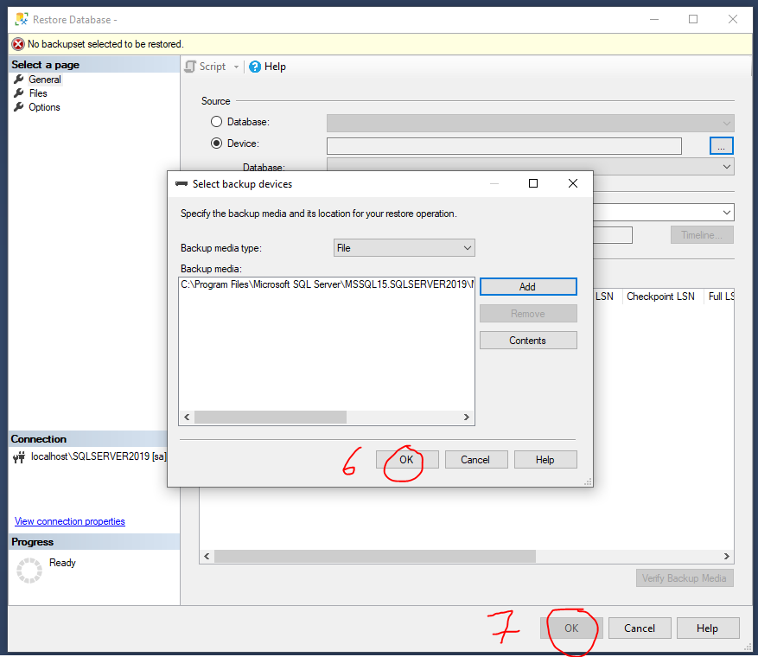

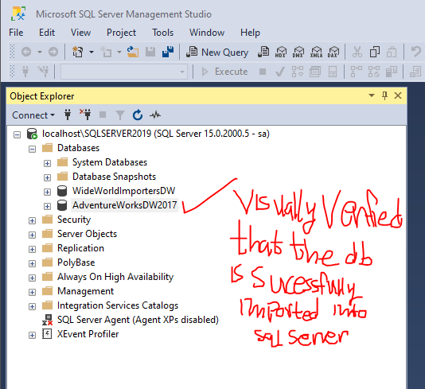

# 1.Data Warehouse Foundations

## 1.1 MSS GUI- Data Warehouse Architecture

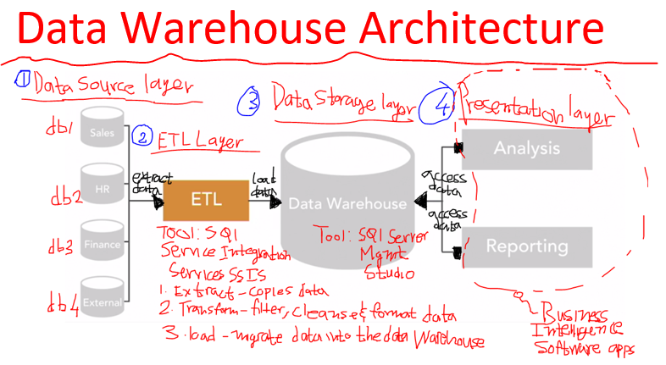

## 1.2 MSS GUI- Star Schema (Mapping of Fact & Dimension Tables)

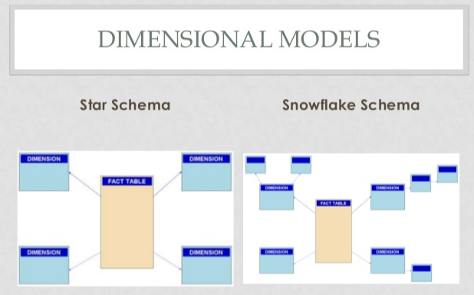

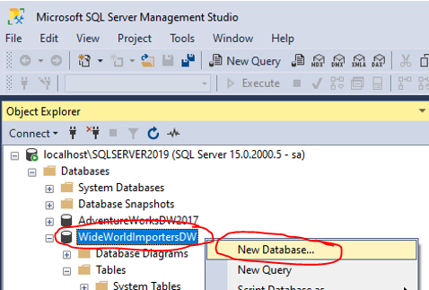

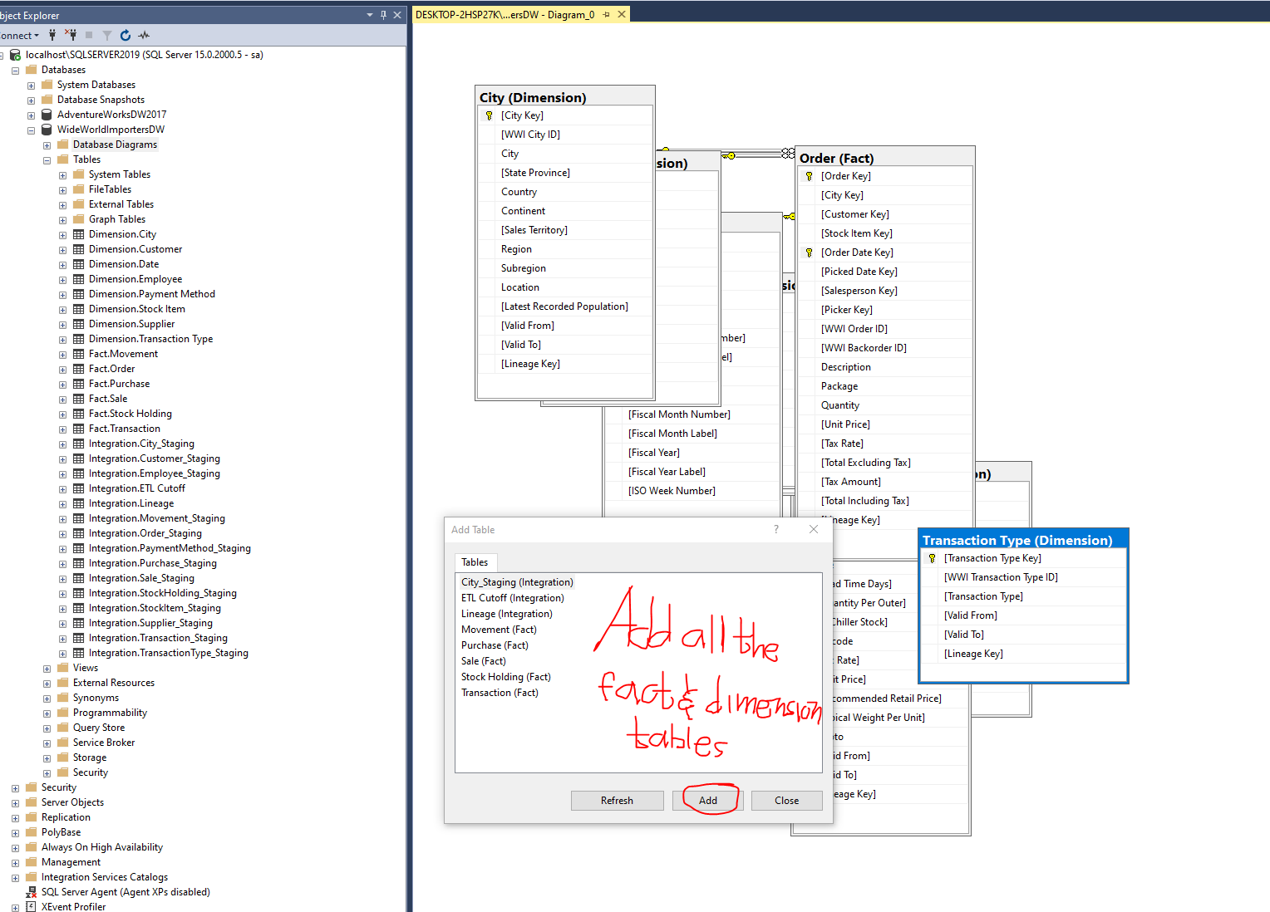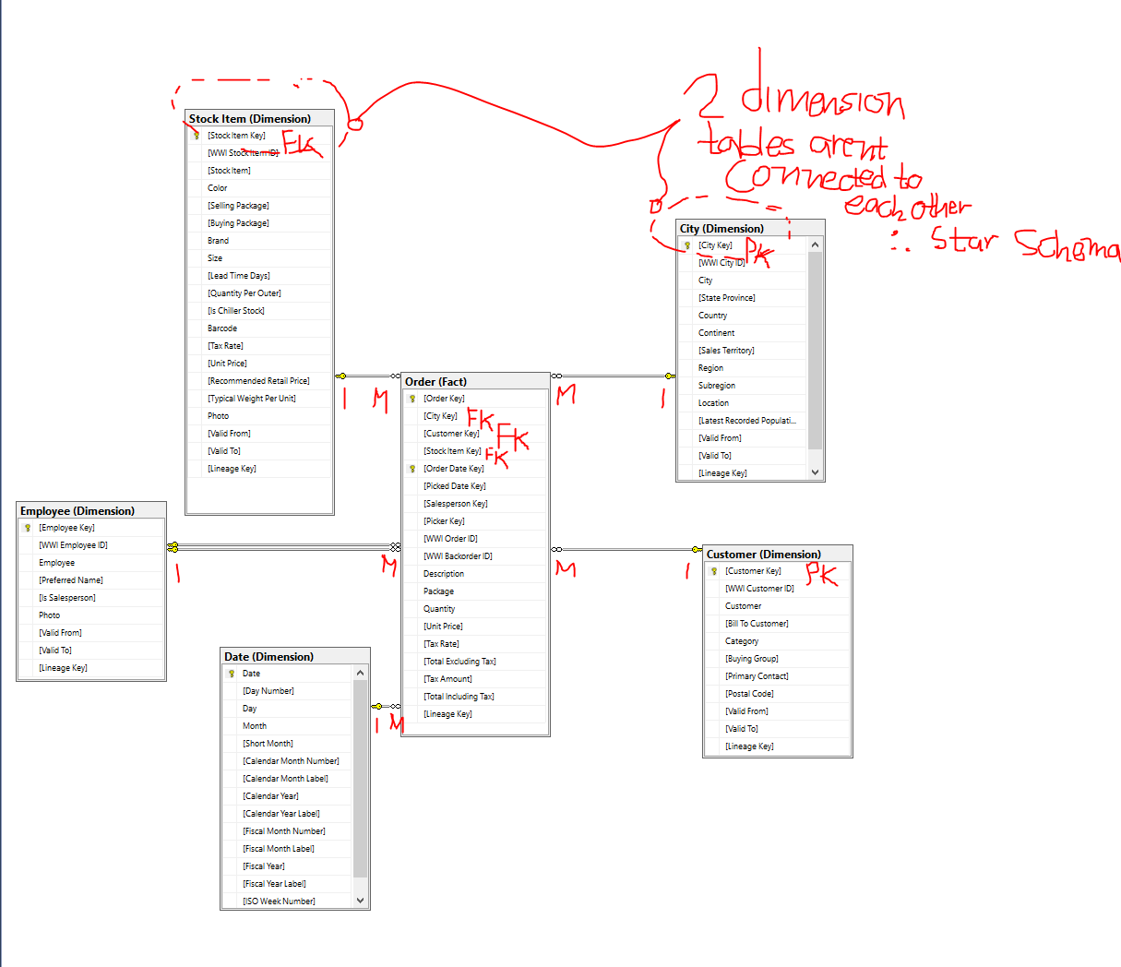

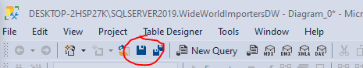

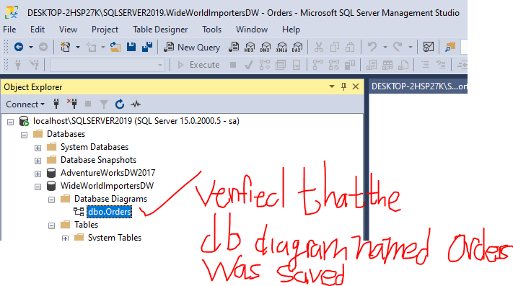

## 1.3 Chapter Quiz

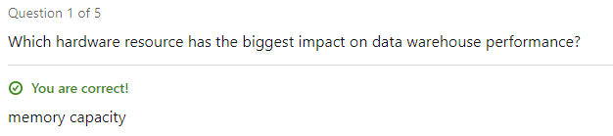

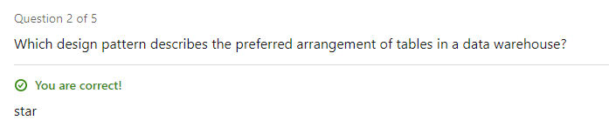

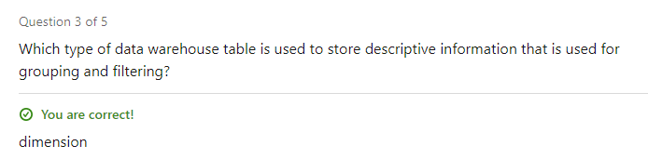

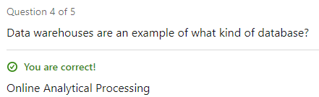

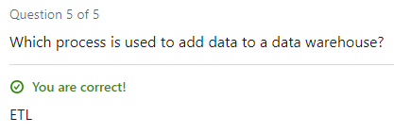

# 2.Create a Data Warehouse

## 2.1 MSS GUI- Creating a Database

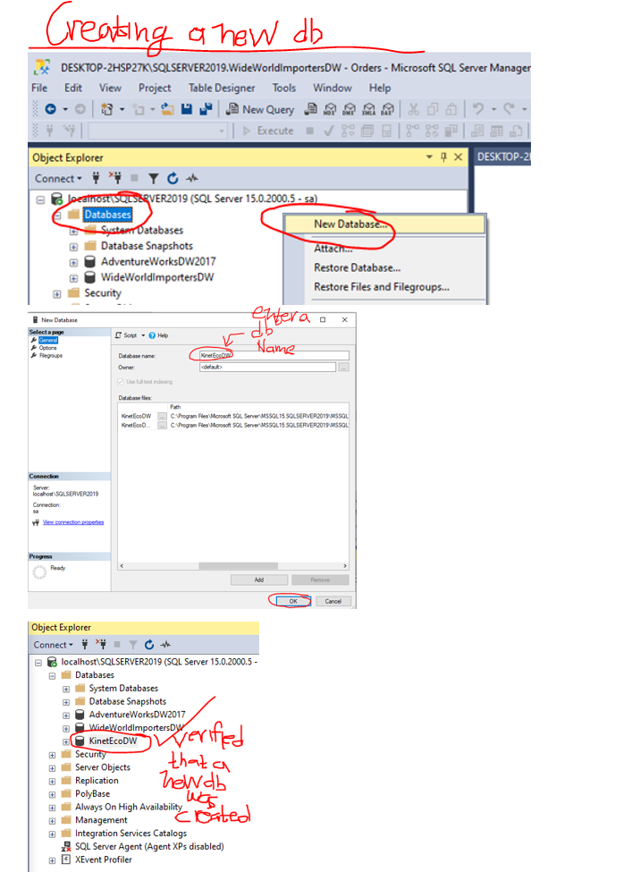

## 2.2 MSS GUI- Creating fact and dimension schemas

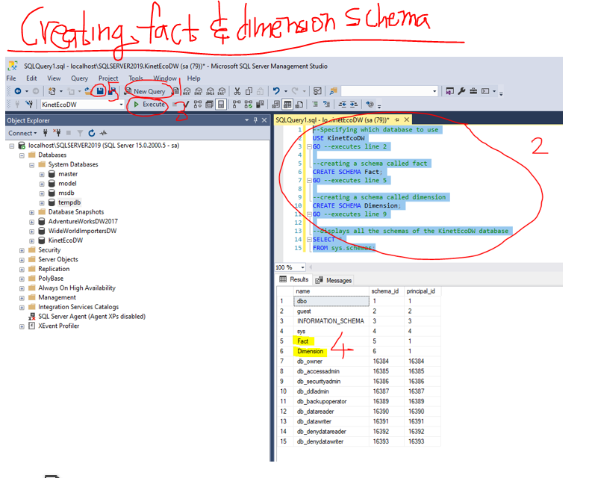



## 2.3 MSS GUI- Creating dimension tables

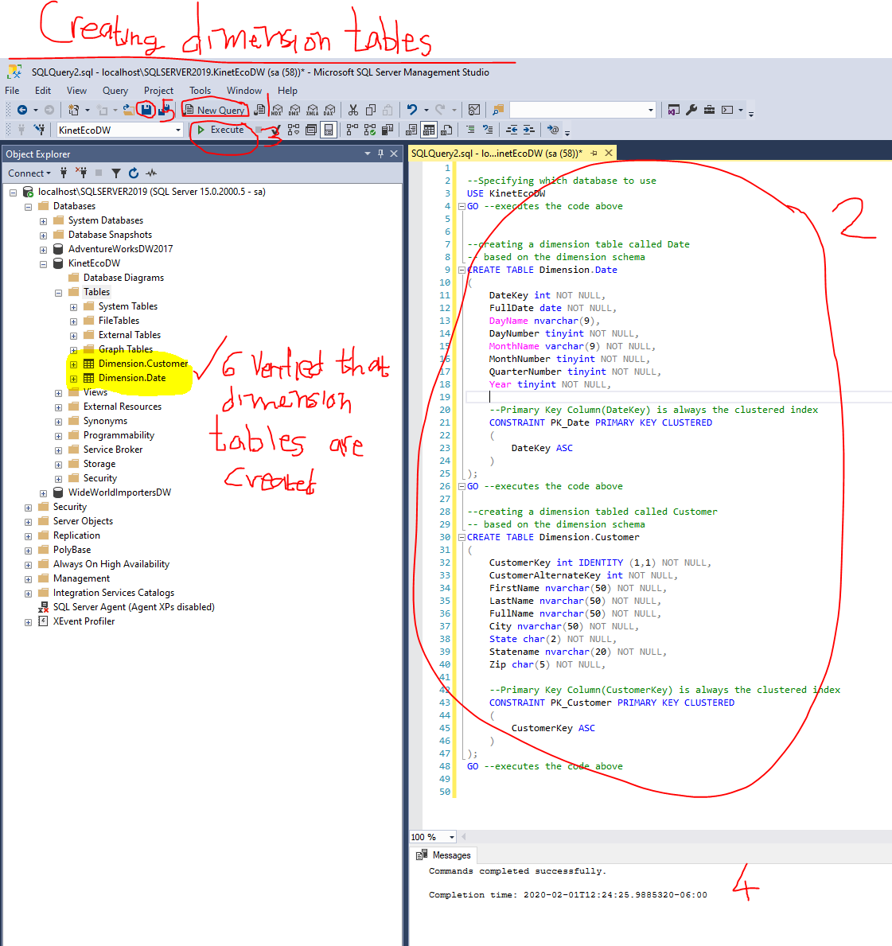



## 2.4 MSS GUI- Creating a fact tables & adding PK-FK Relationships

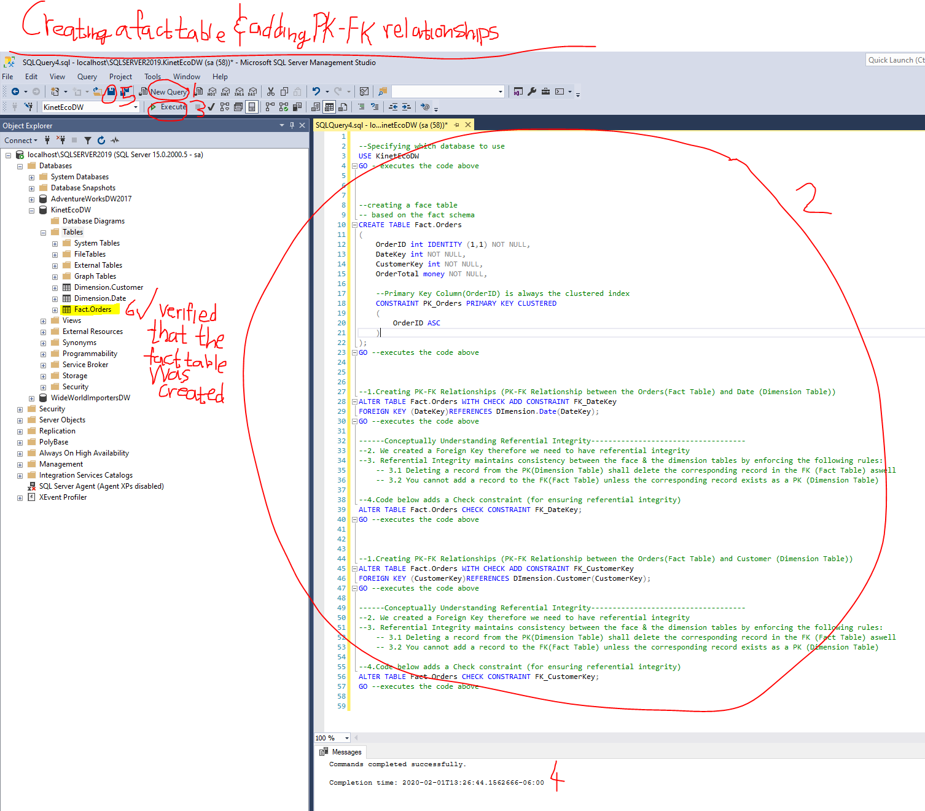



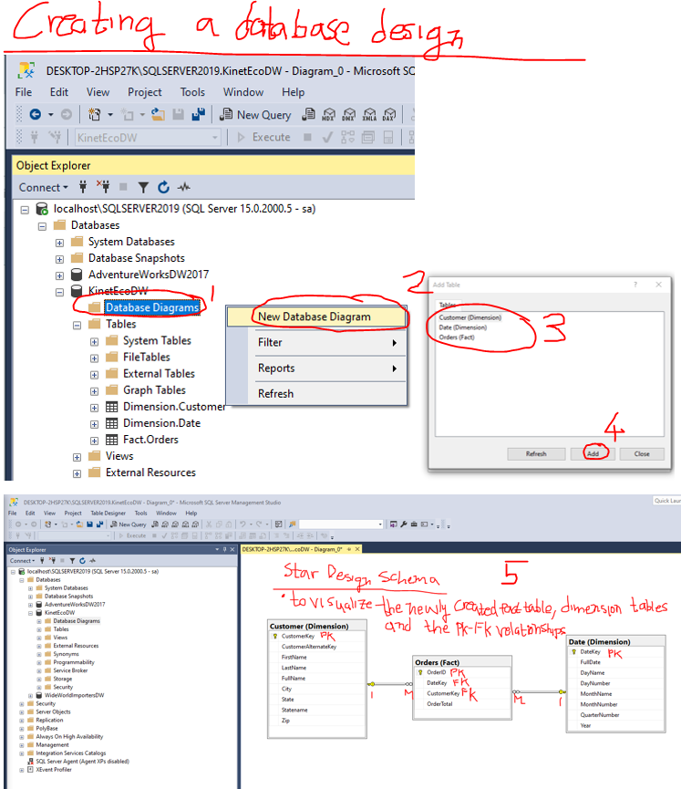

## 2.5 MSS GUI- Creating an indexed view

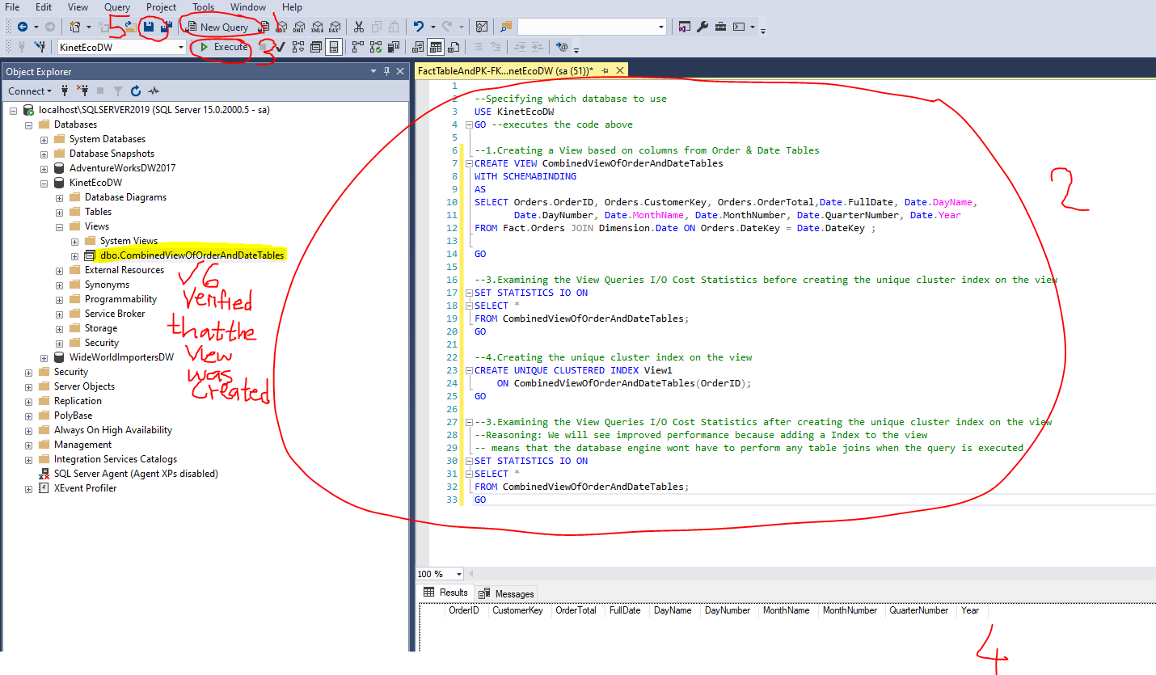



## 2.6 Chapter Quiz

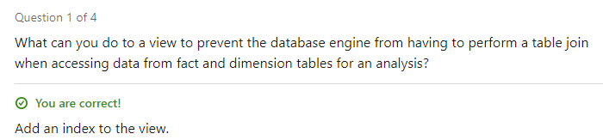

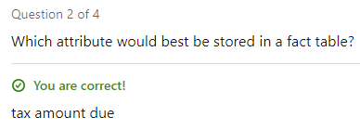

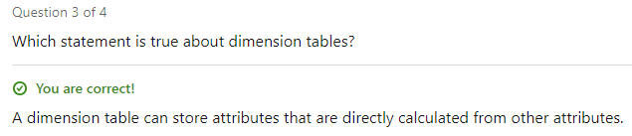

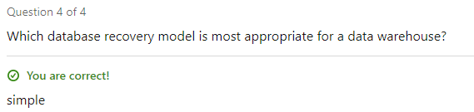

# 3.MSS GUI- Columnstore Indexes

## 3.1 MSS GUI- Creating a Column Store Index (To Improve Query Performance)

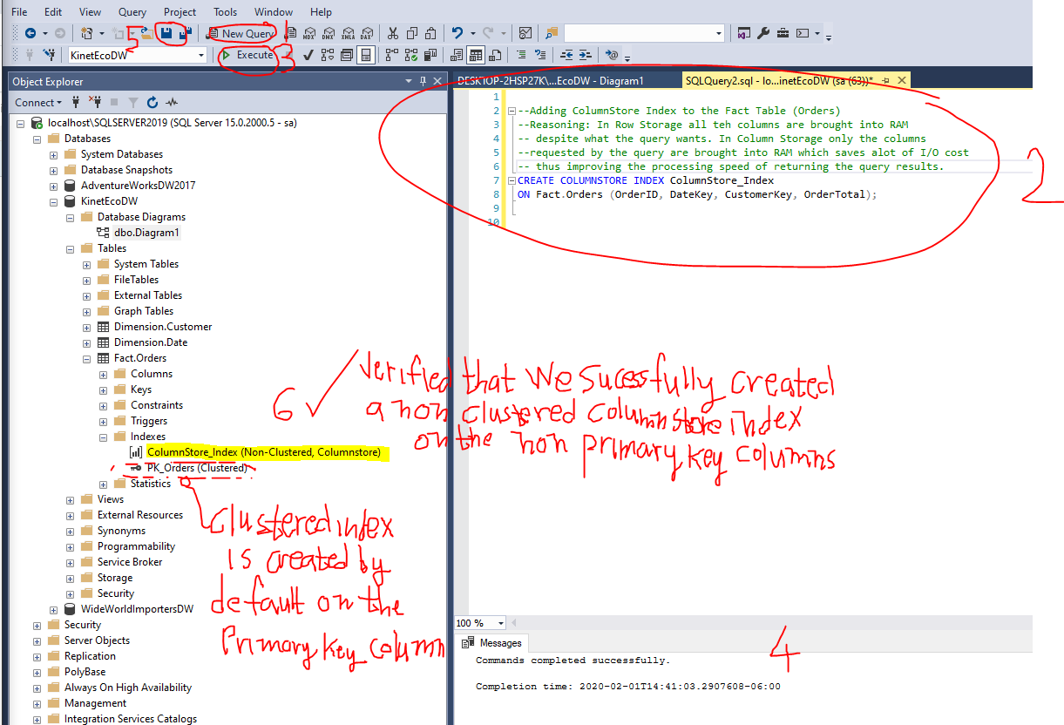



## 3.2 MSS GUI- Creating a Memory Optimized Column Store Table (To Improve Query Performance)

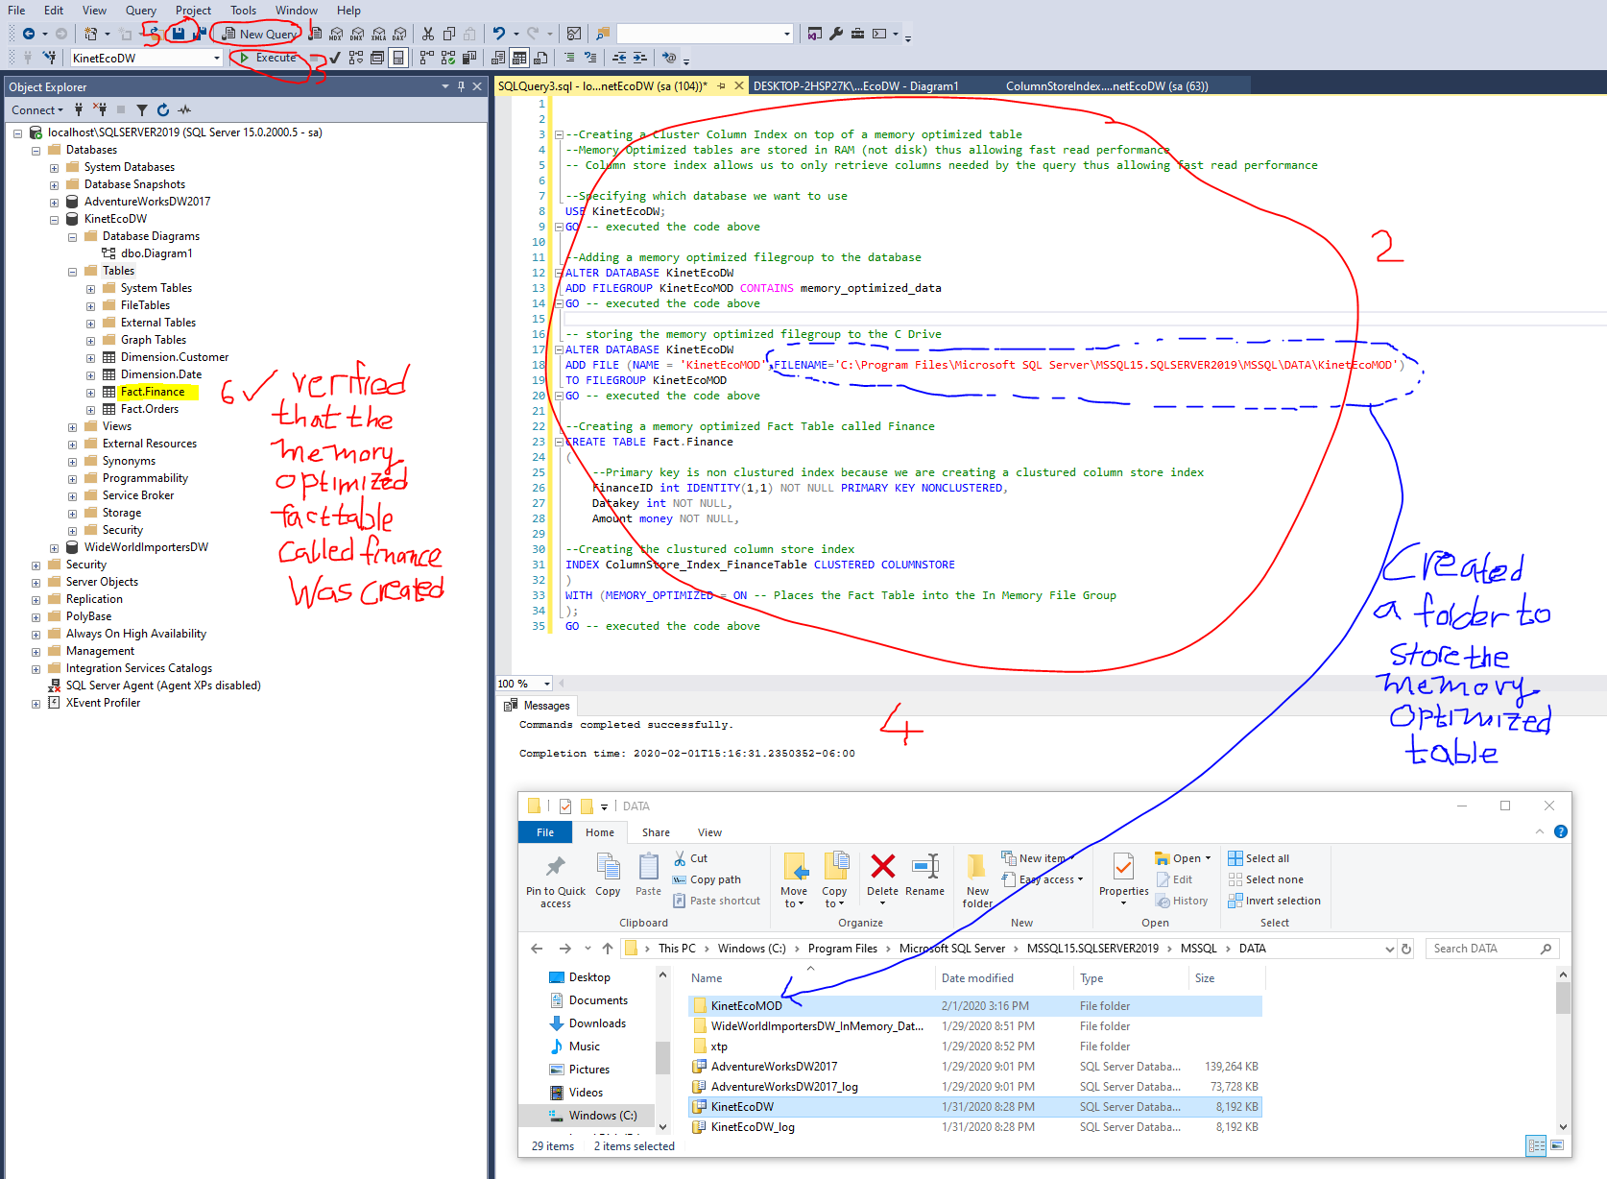



## 3.3 MSS GUI- Rebuilding Index (To Improve Query Performance)

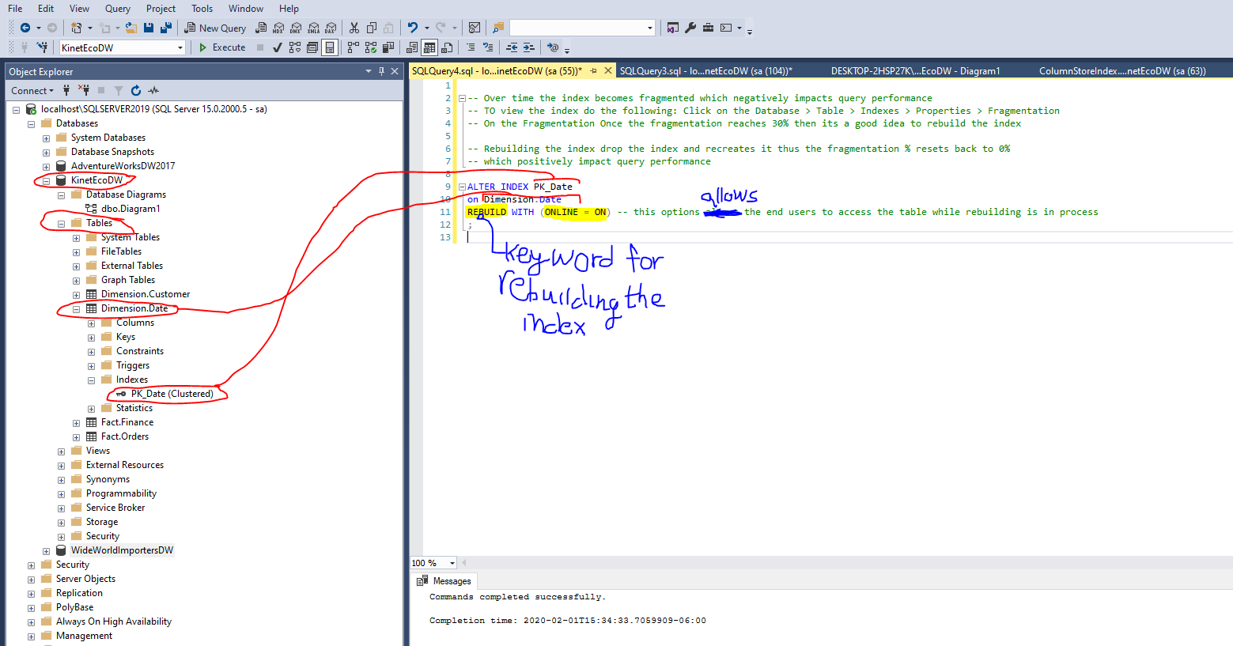



## 3.4 Chapter Quiz

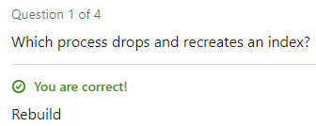

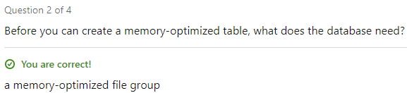

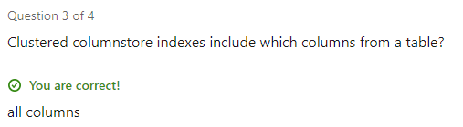

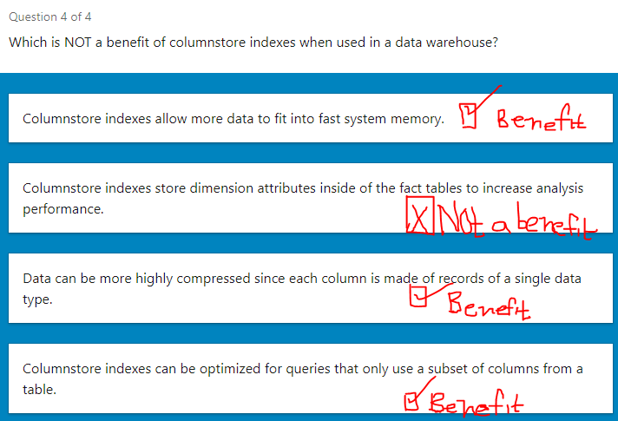

# 4.Implement an Azure SQL Datawarehouse (Runs on the Cloud)

## 4.1 Creating an Azure SQL Datawarehouse

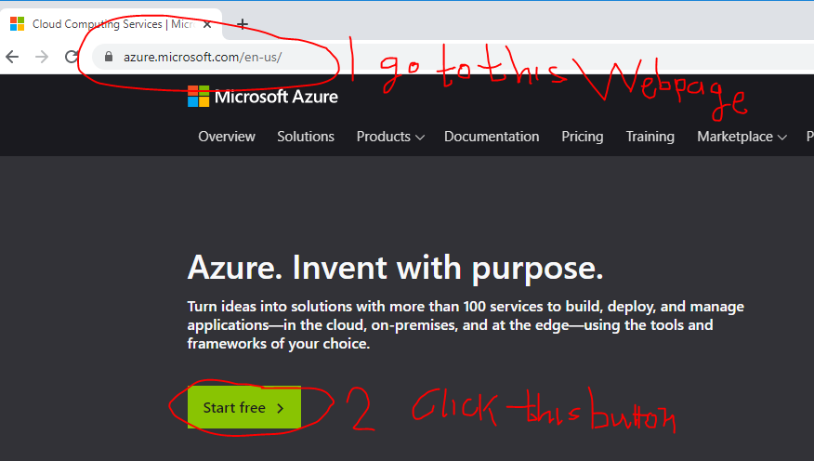

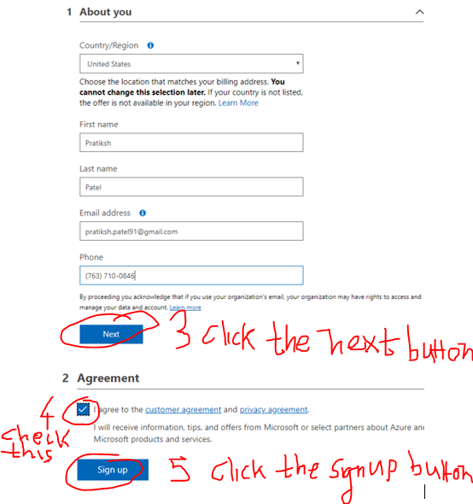

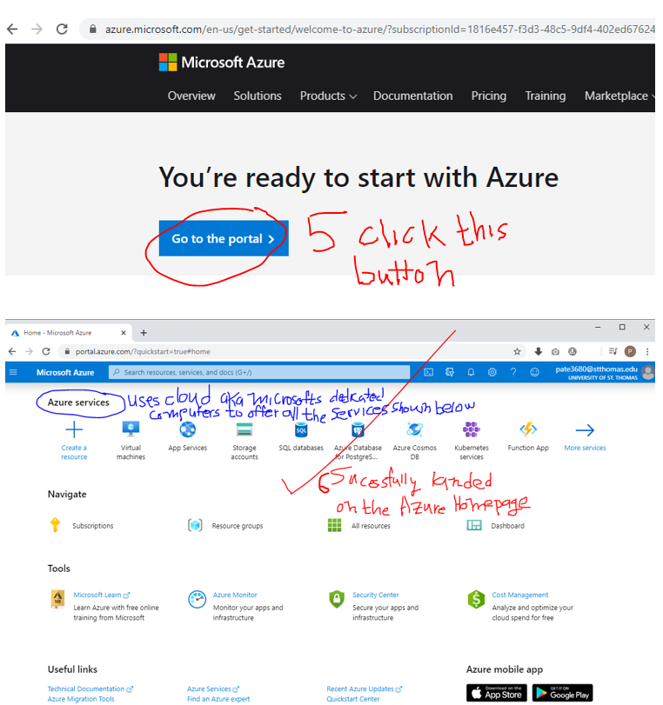

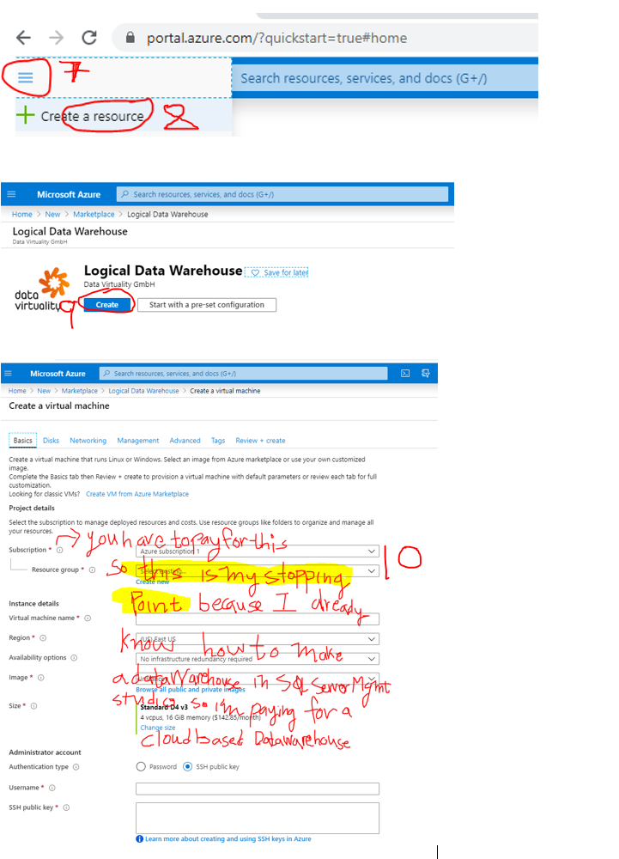

## 4.2 Chapter Quiz

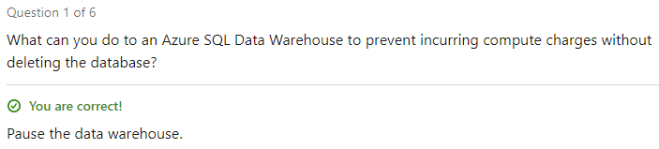

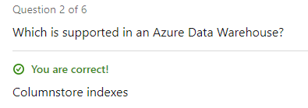

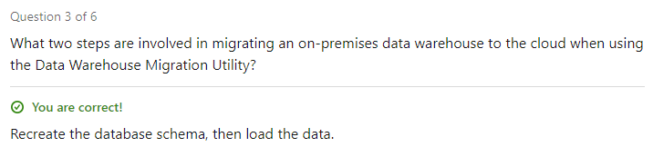

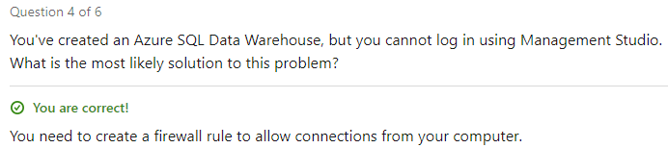

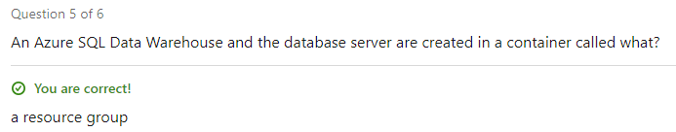

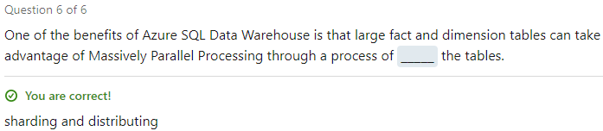

# 5.Extract, Transform and Load (ETL)

## 5.1 Chapter Quiz

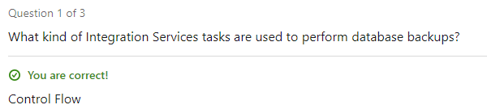

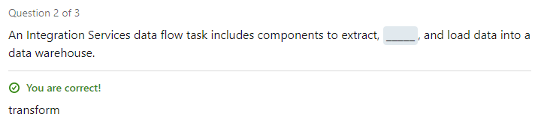

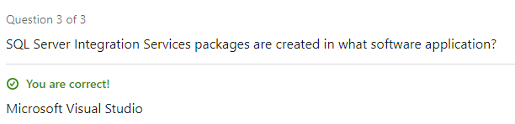

# 6.Enforce Data Quality (Clean data after its loaded into data warehouse)

## 6.1 Installing the (SQL Server Data Quality Services) Plugin for the MSS GUI

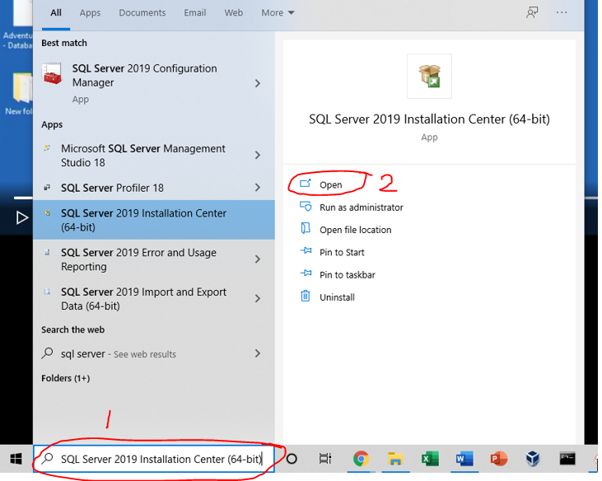

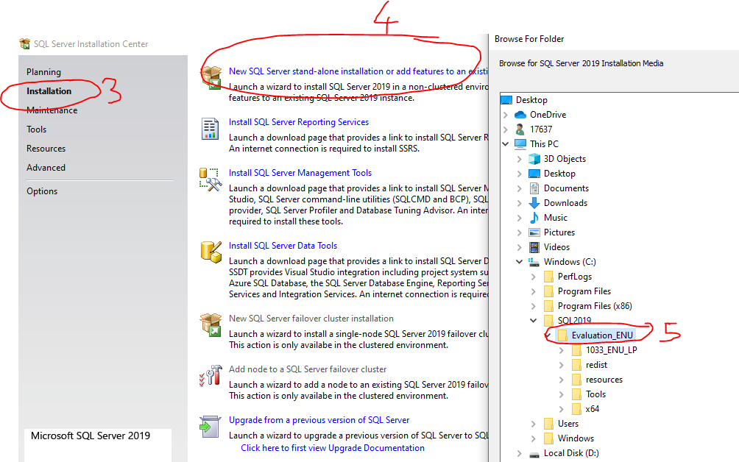

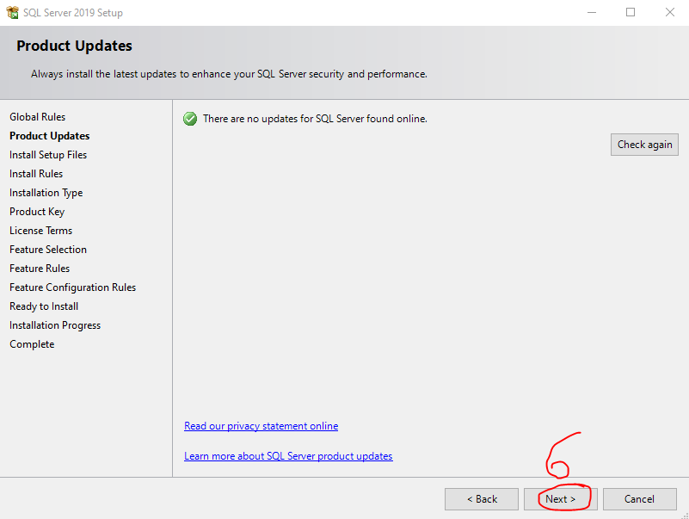

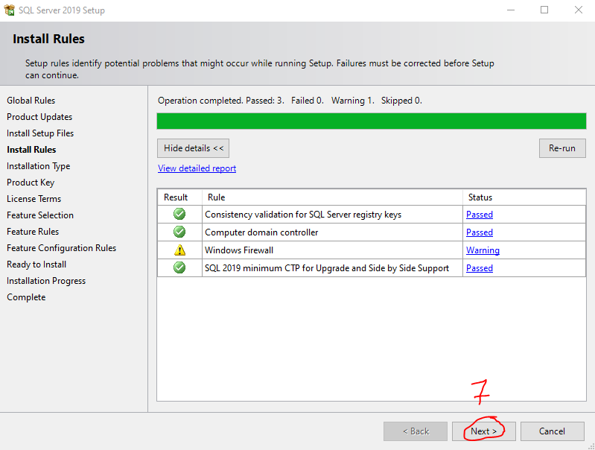

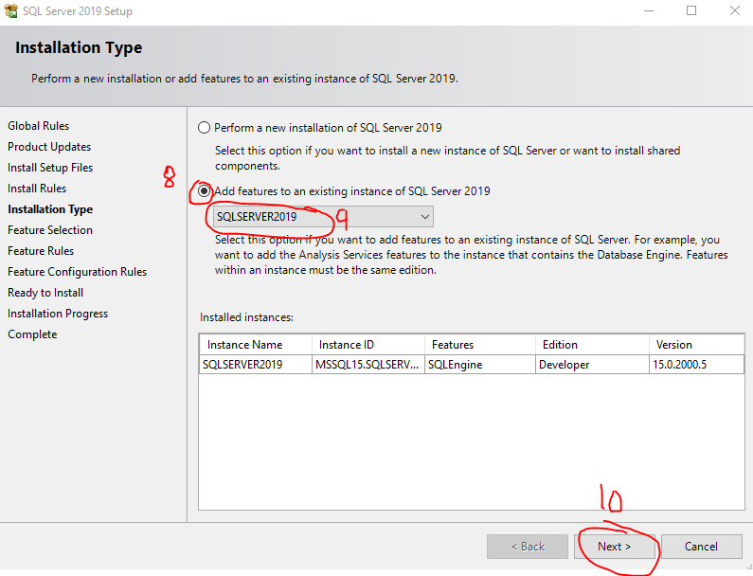

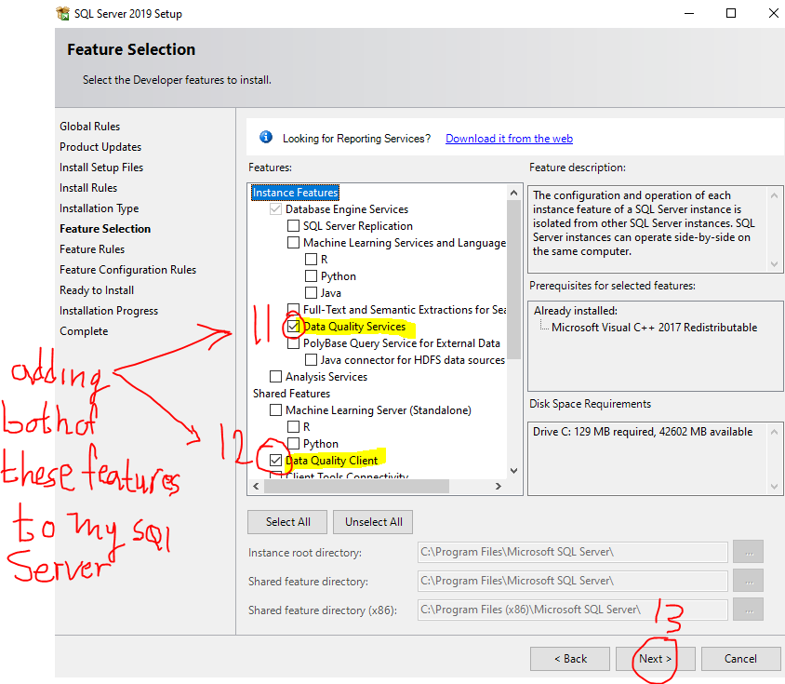

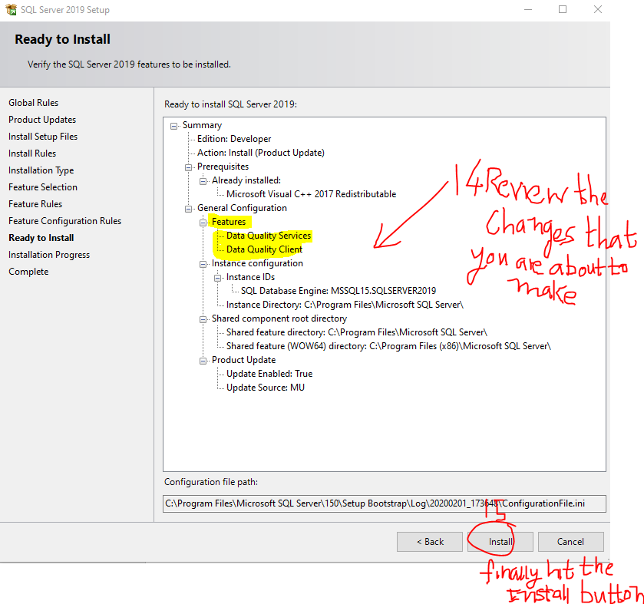

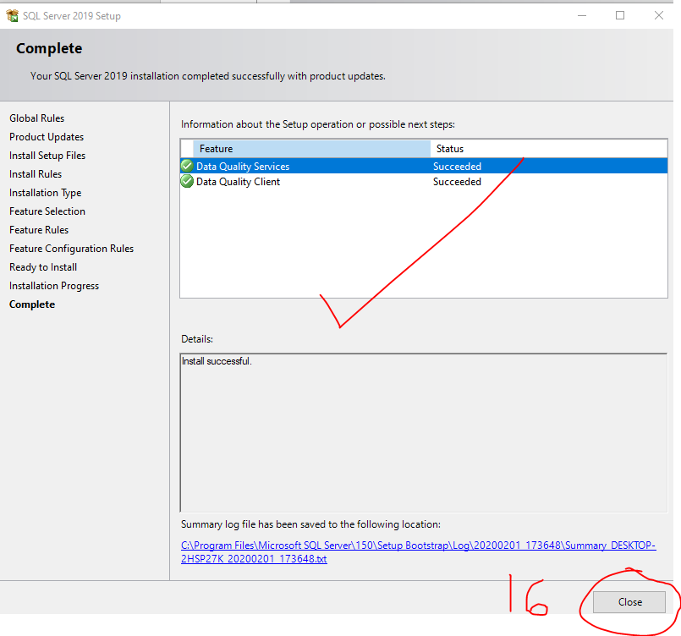

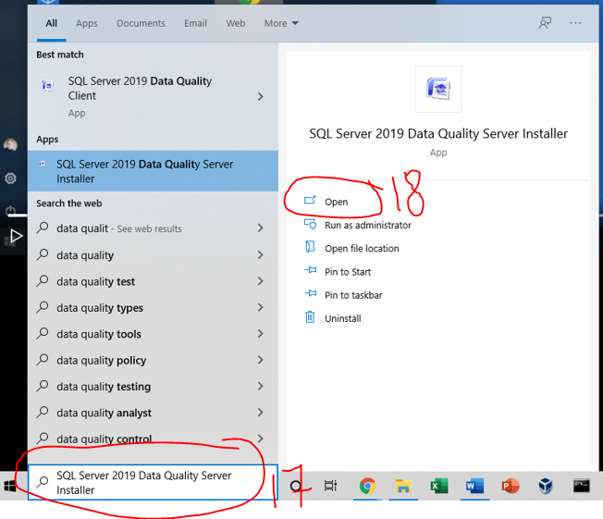

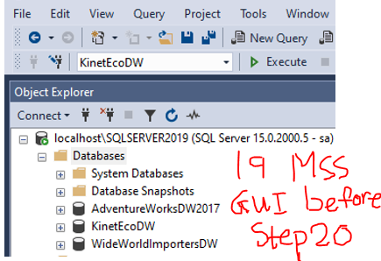

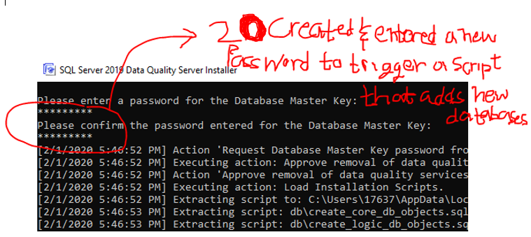

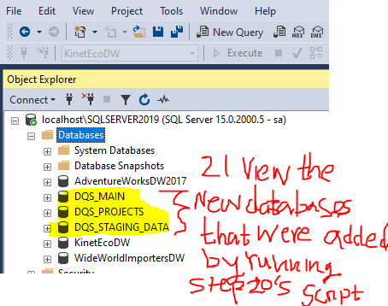

## 6.2 Cleanse Data using the DQS Tool’s Default Knowledge Base

Cleansing data =process of comparing new data against known and verified values to make sure that the new data meets expectations.

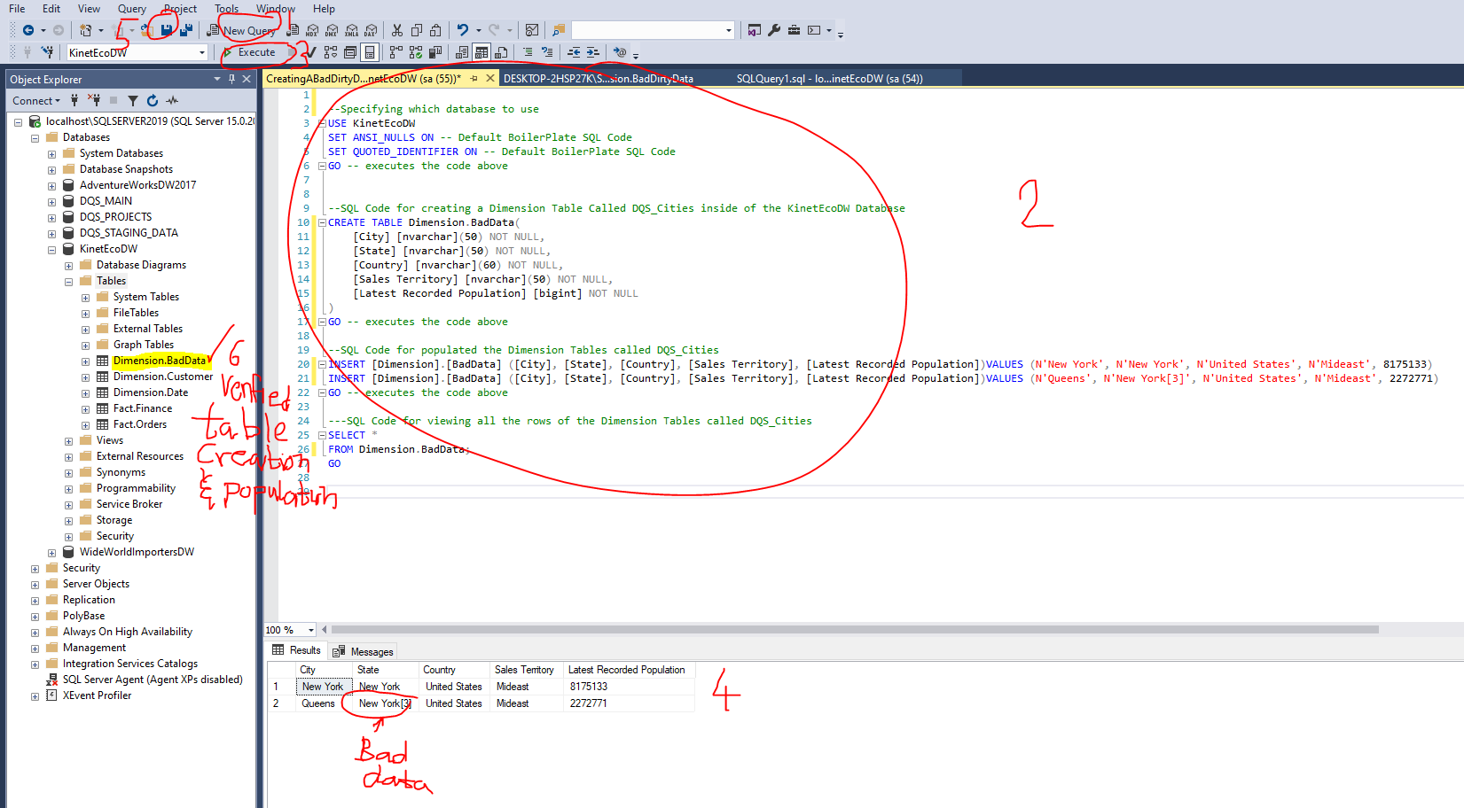



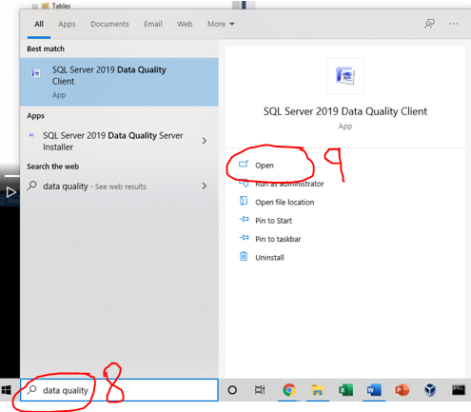

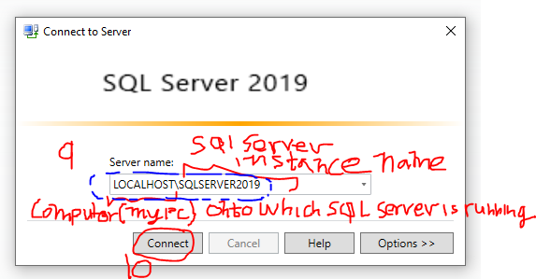

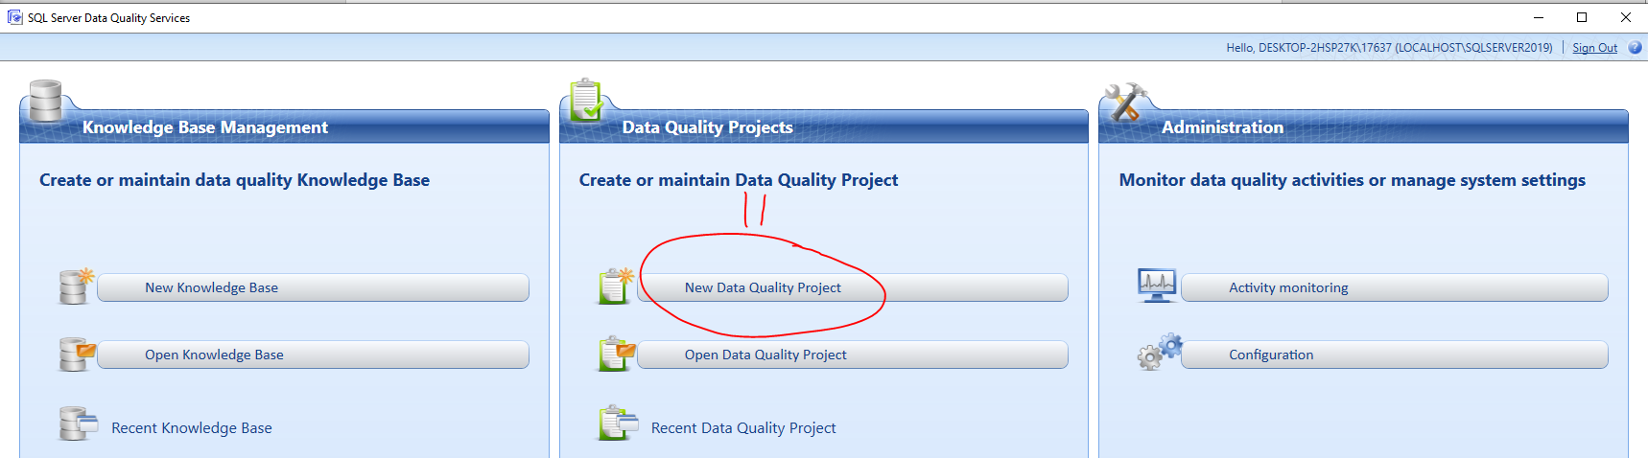

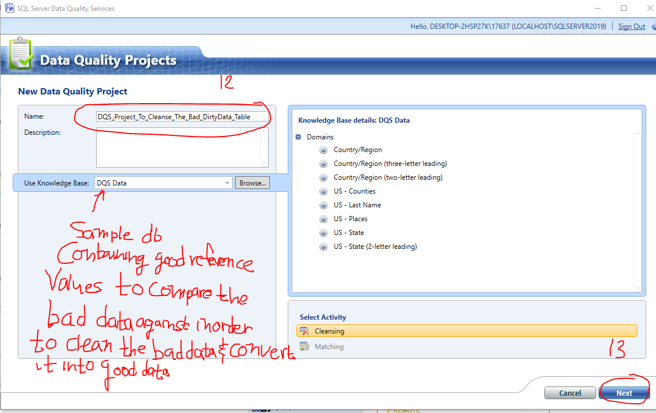

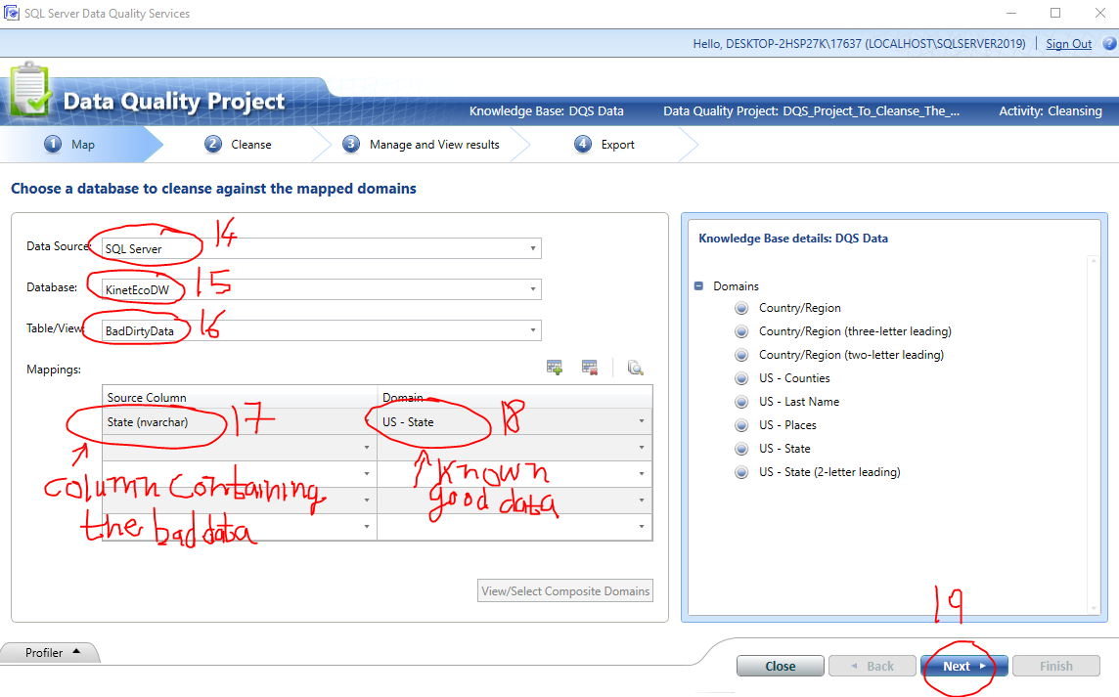

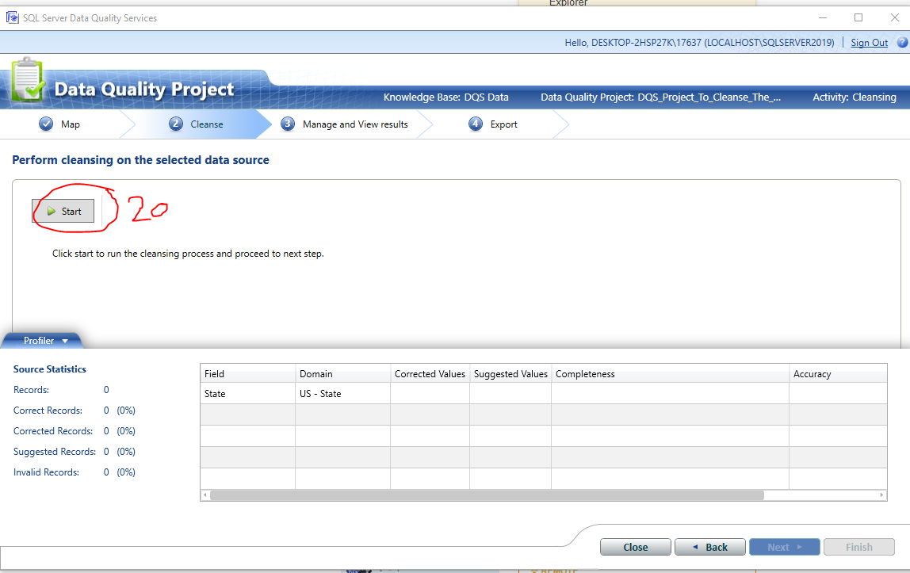

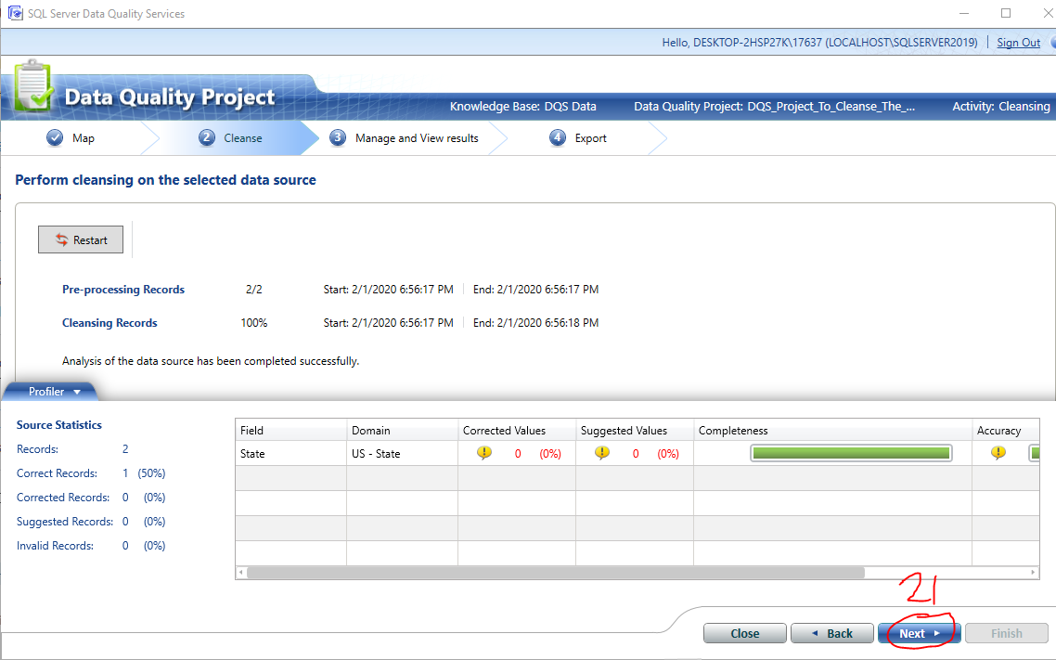

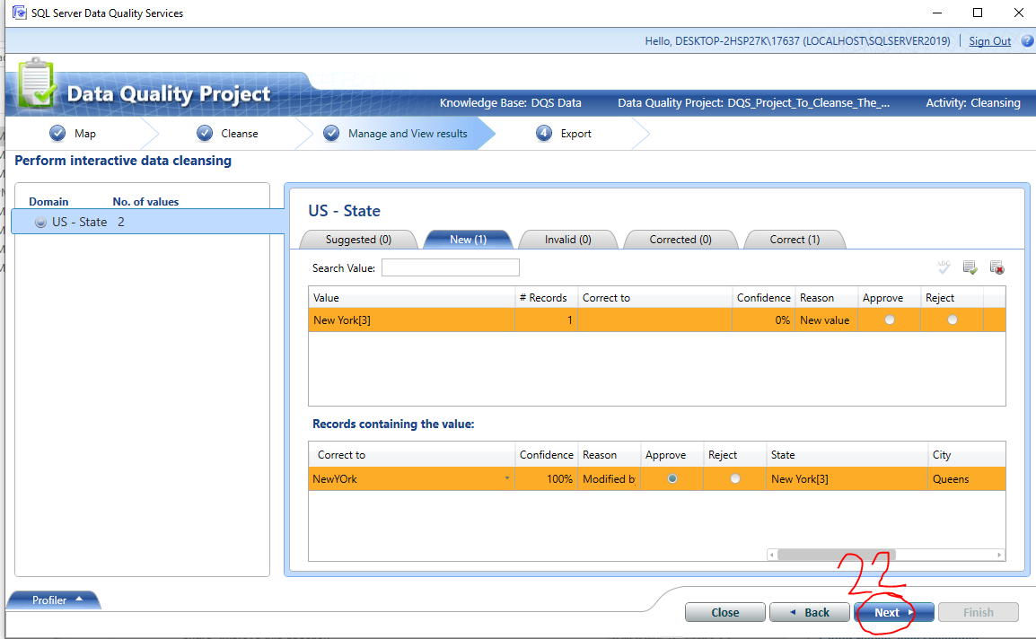

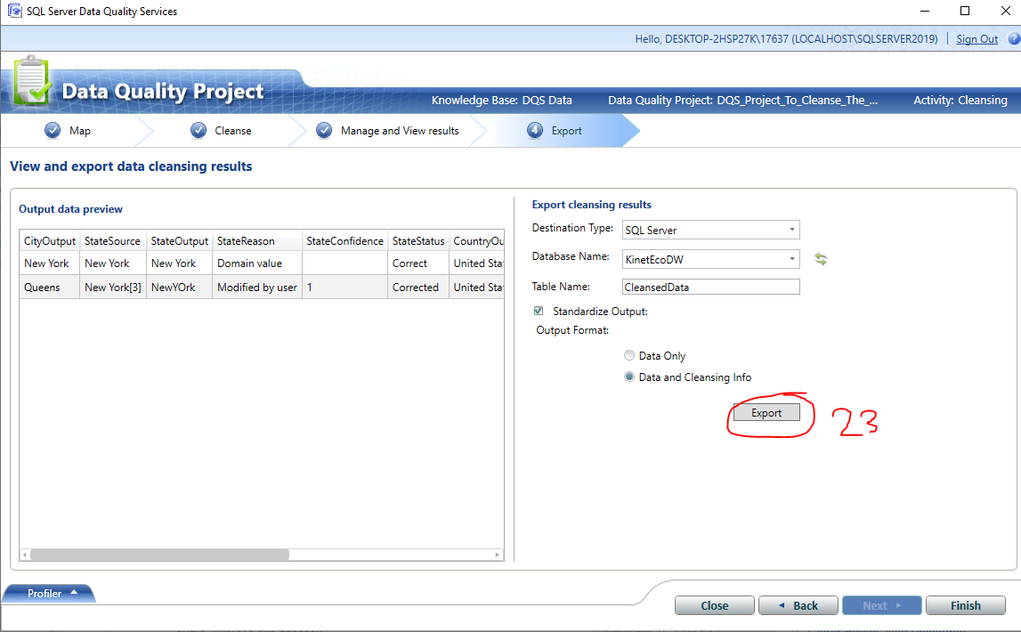

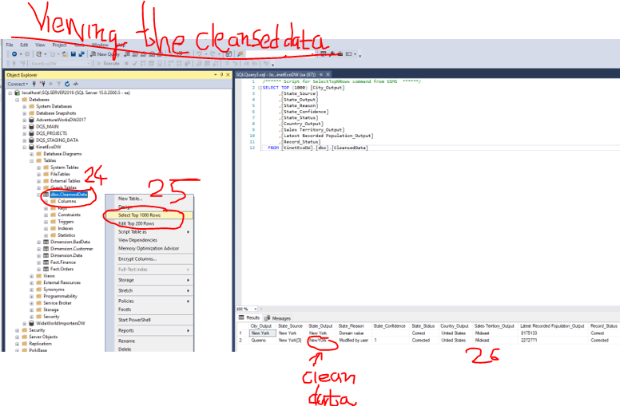

## 6.3 Cleanse Data using the DQS Tool’s Custom Knowledge Base

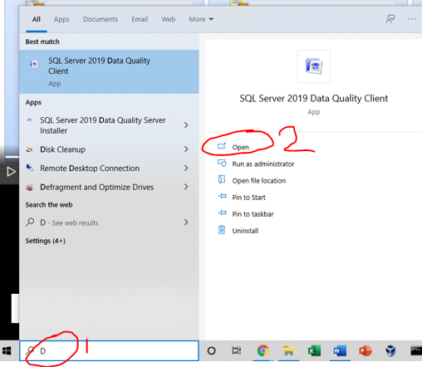

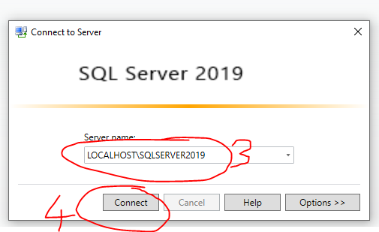

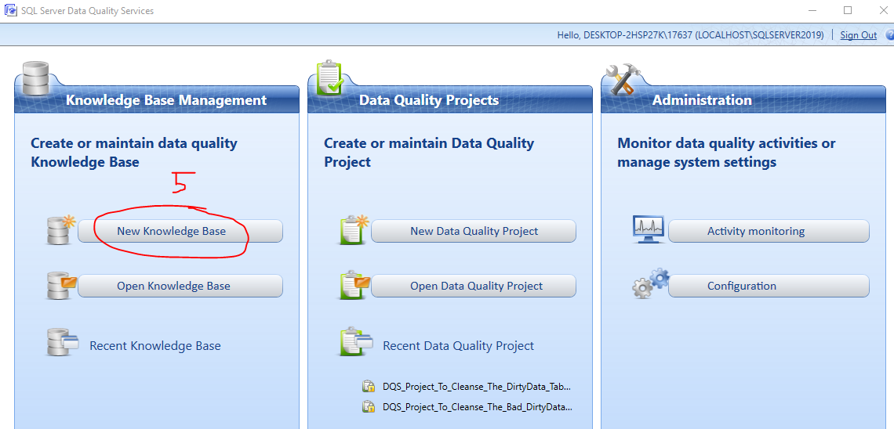

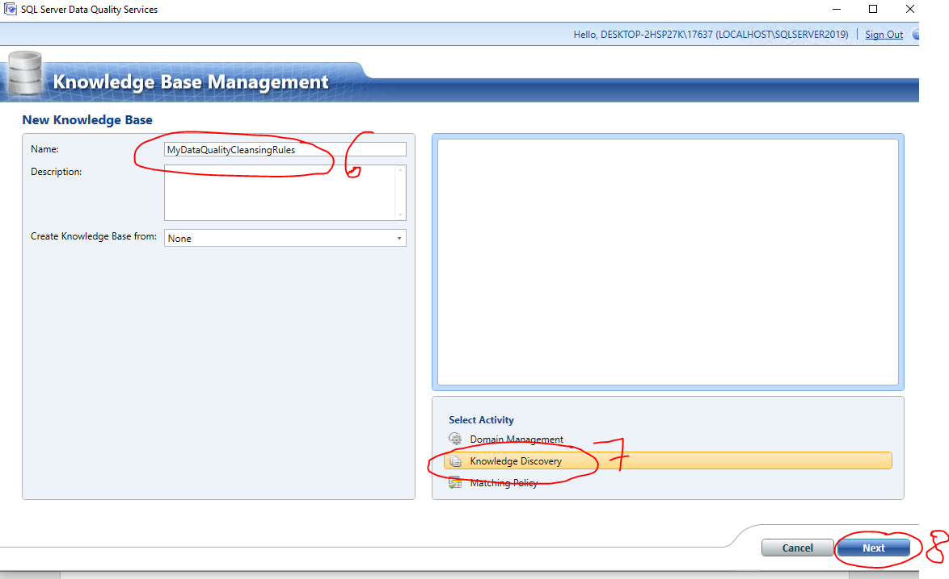

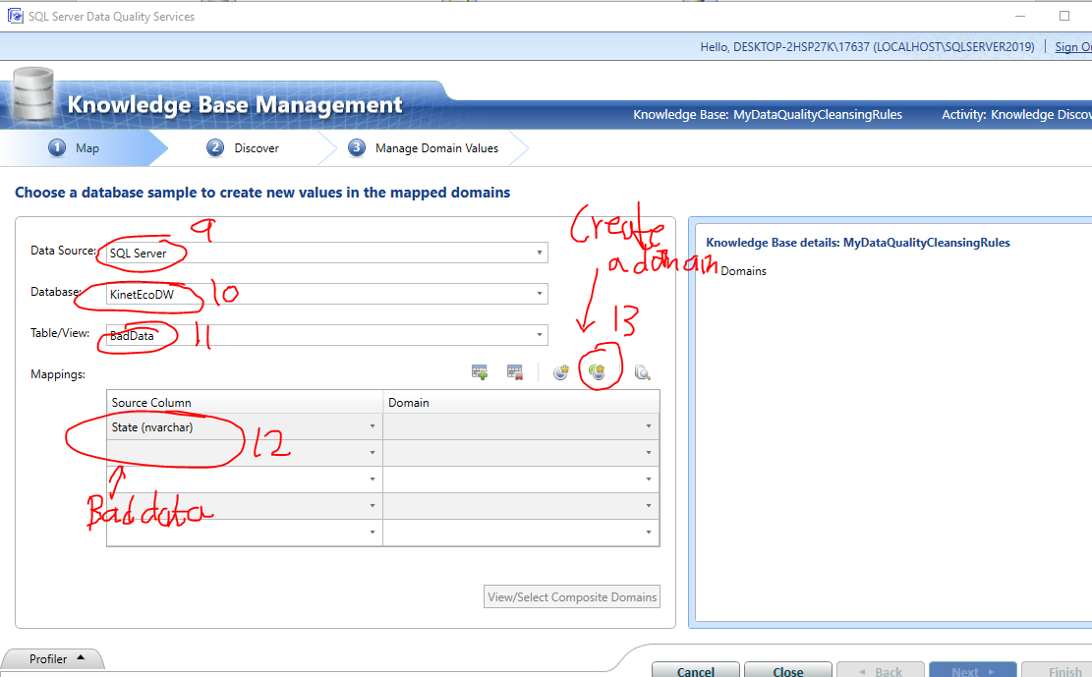

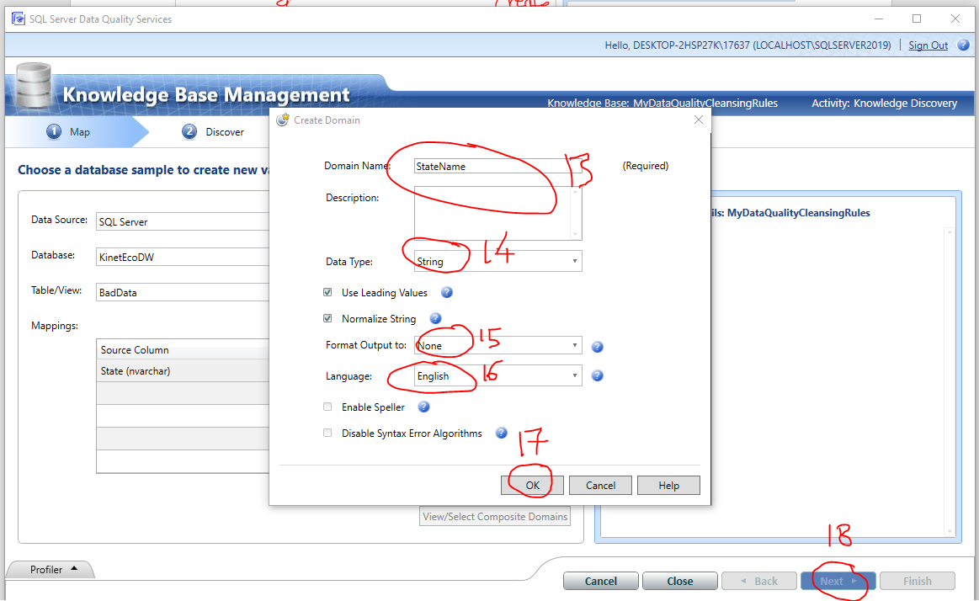

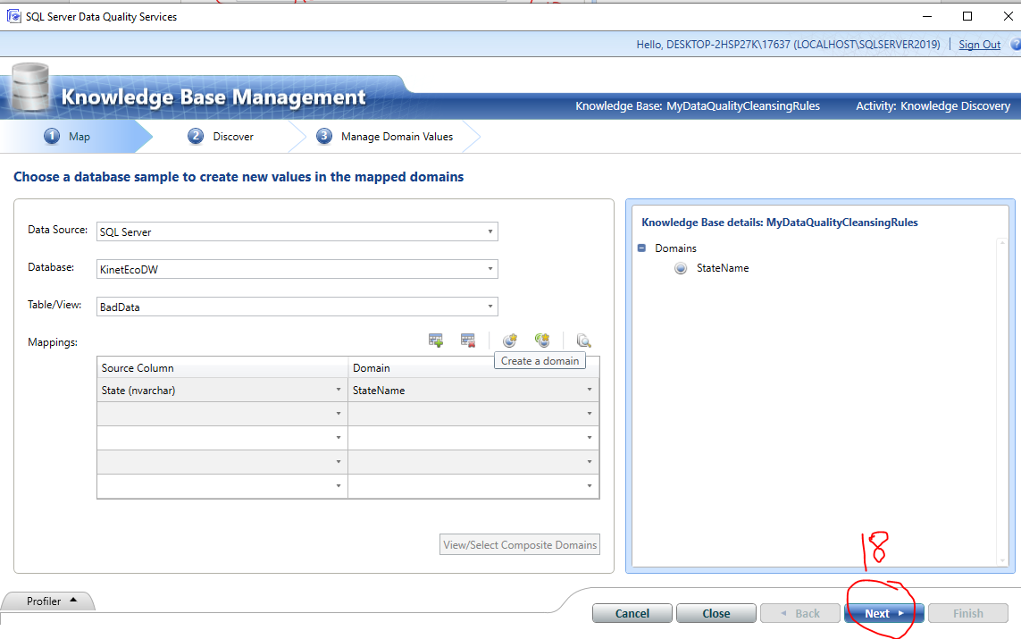

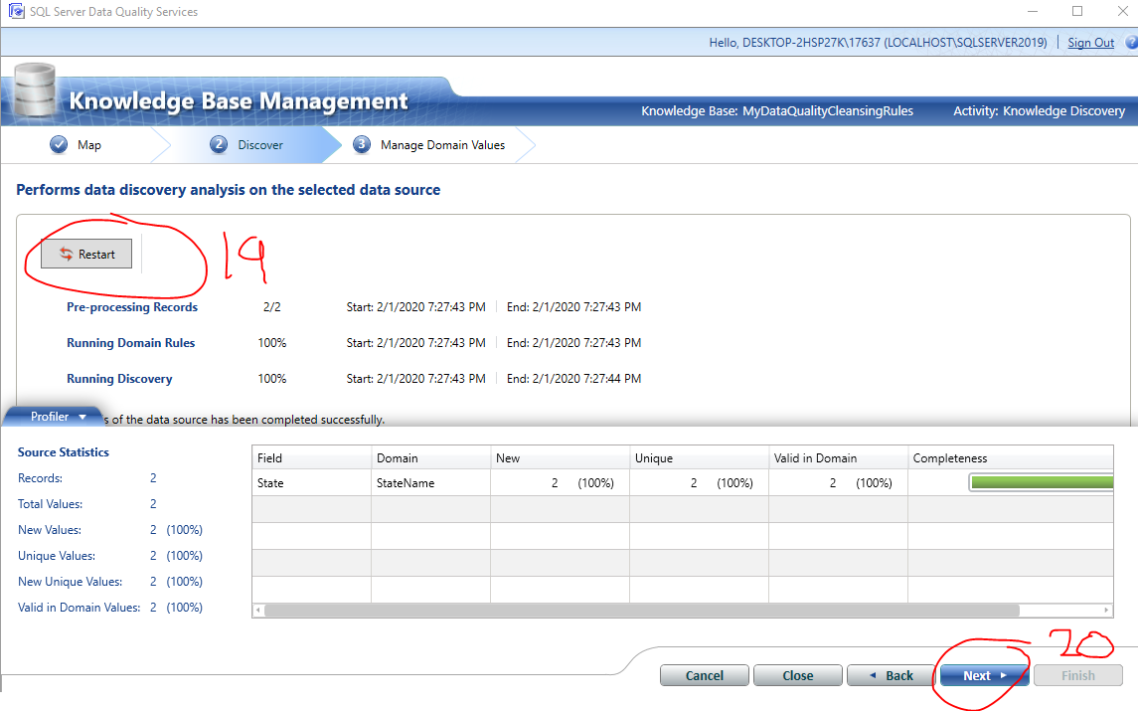

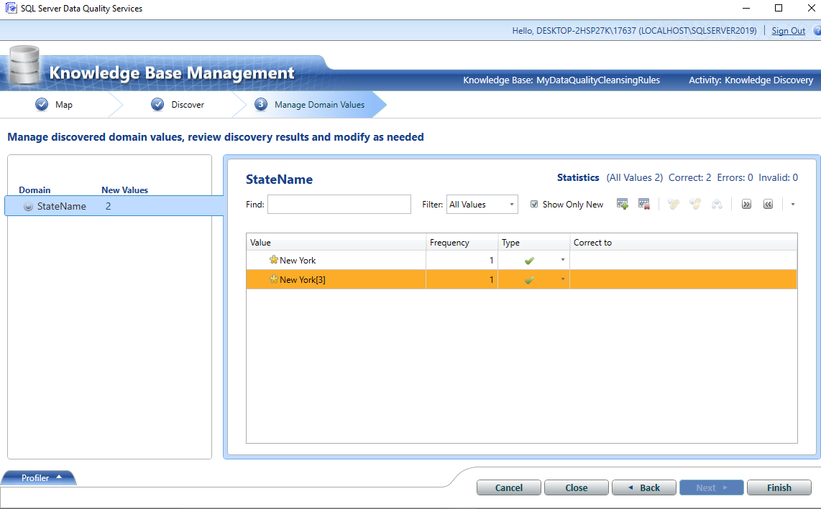

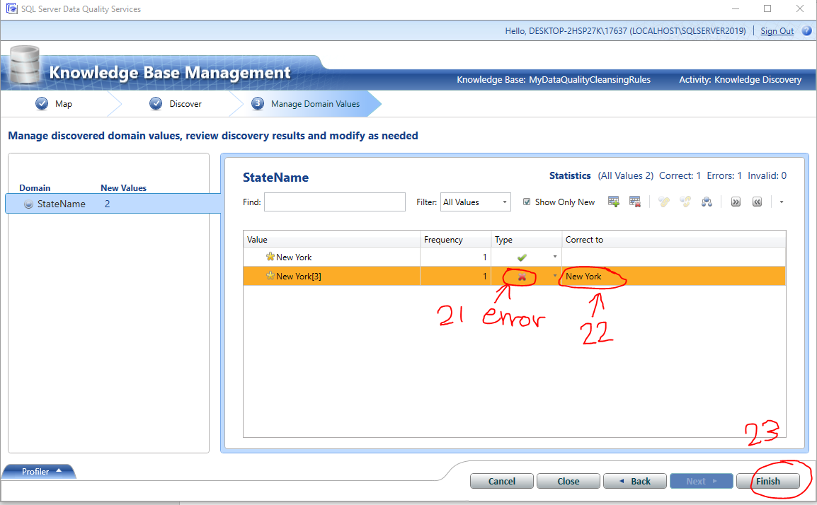

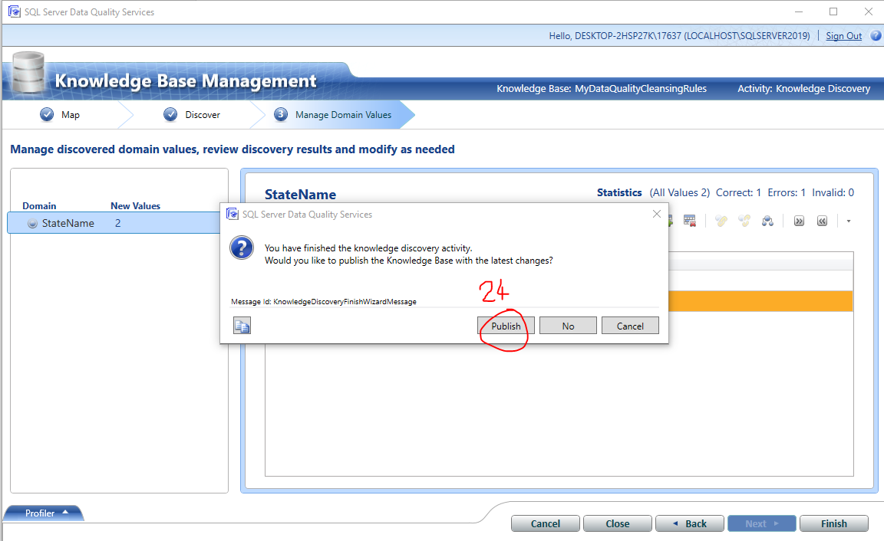

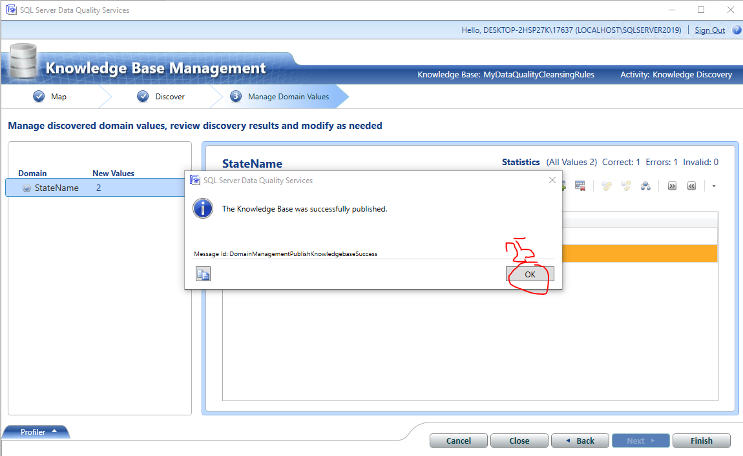

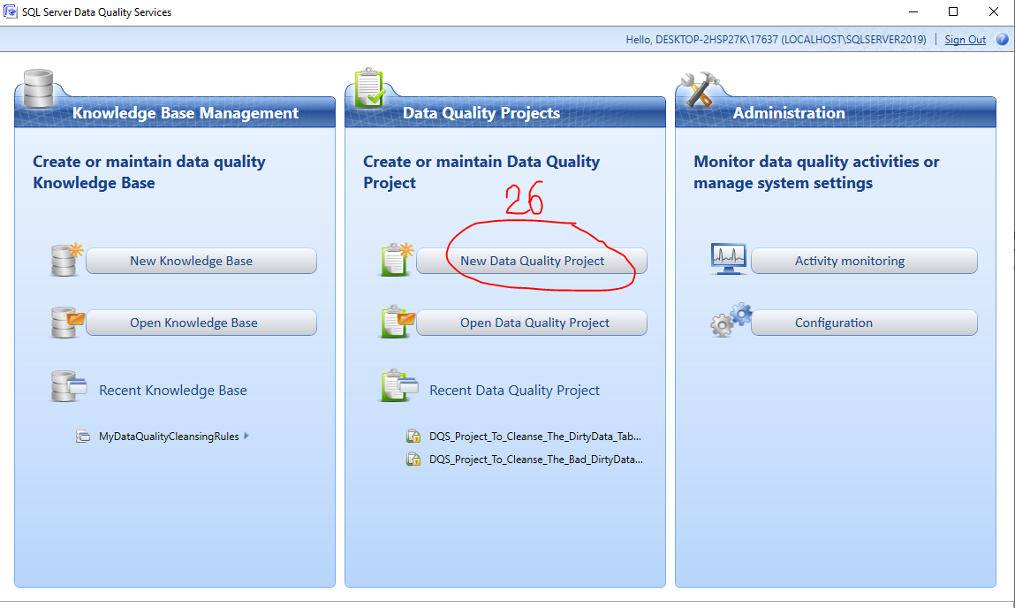

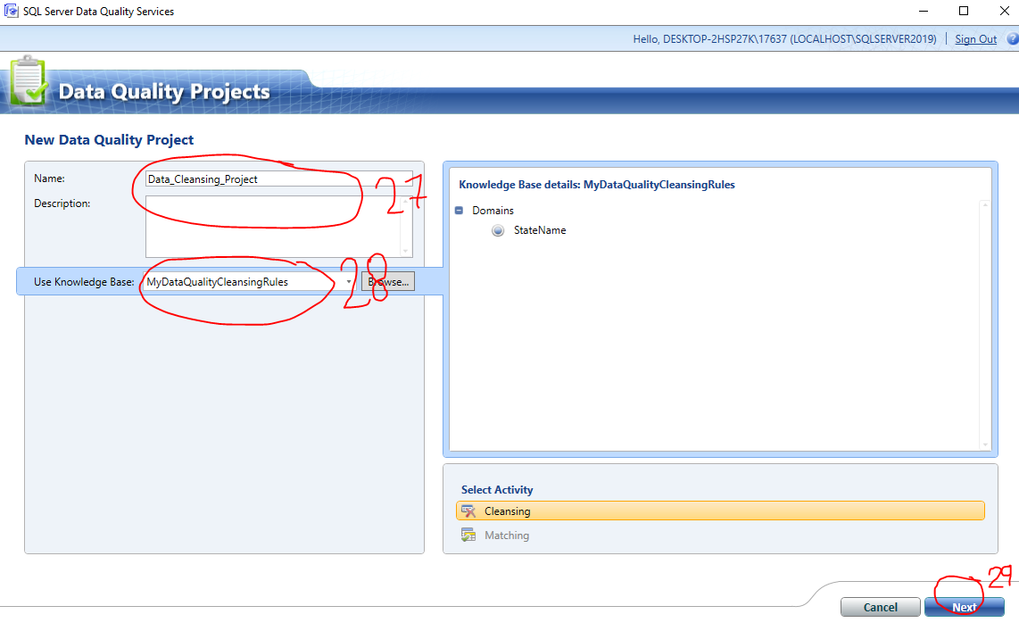

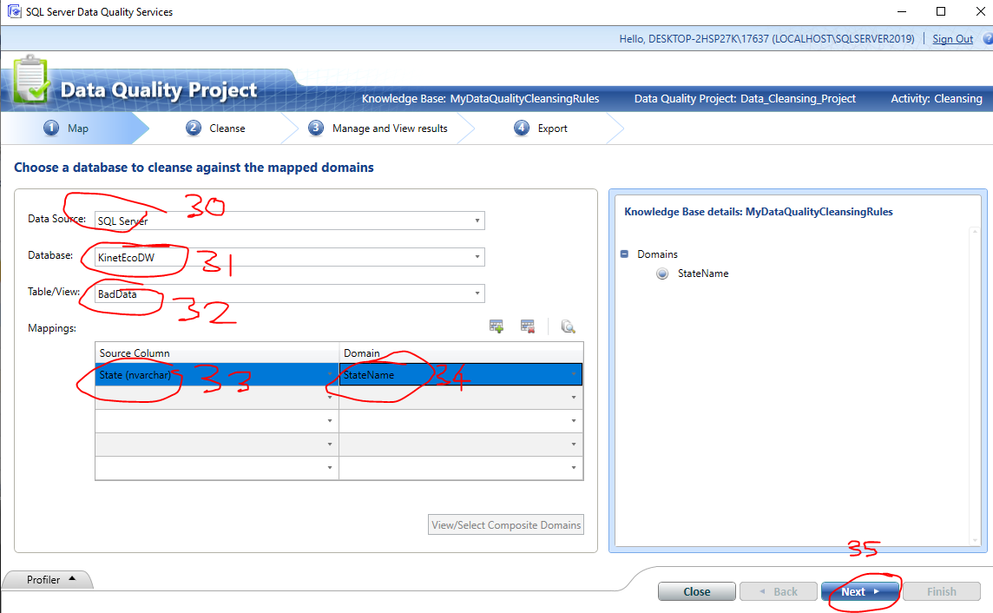

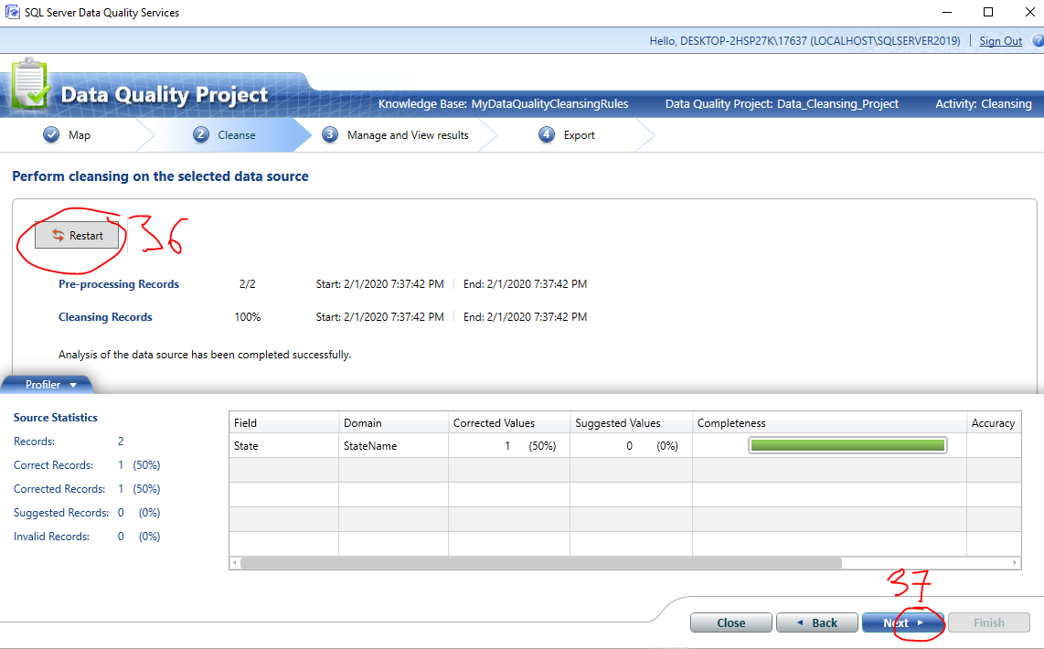

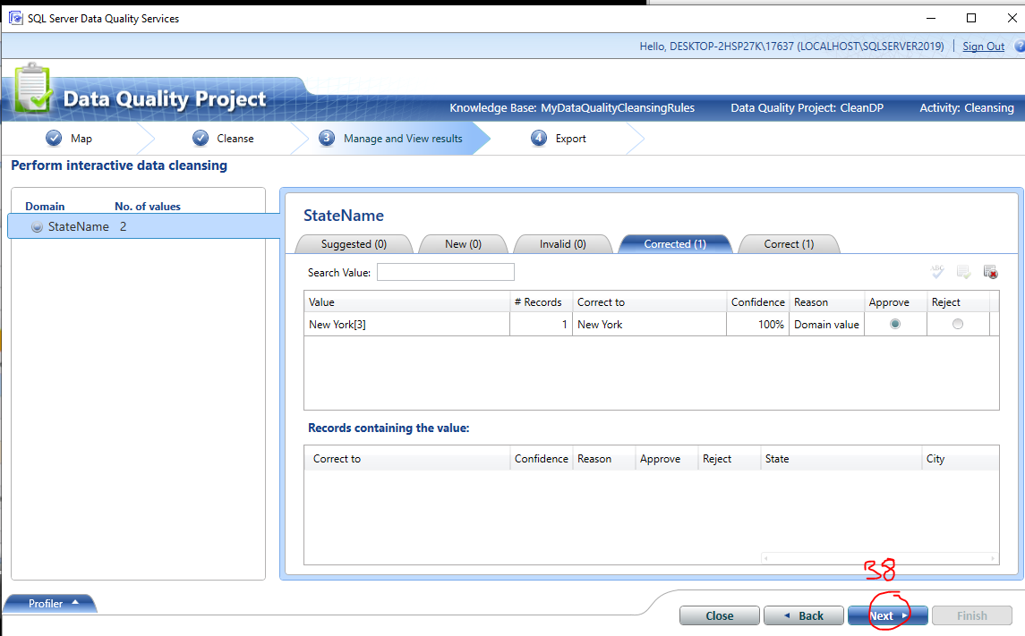

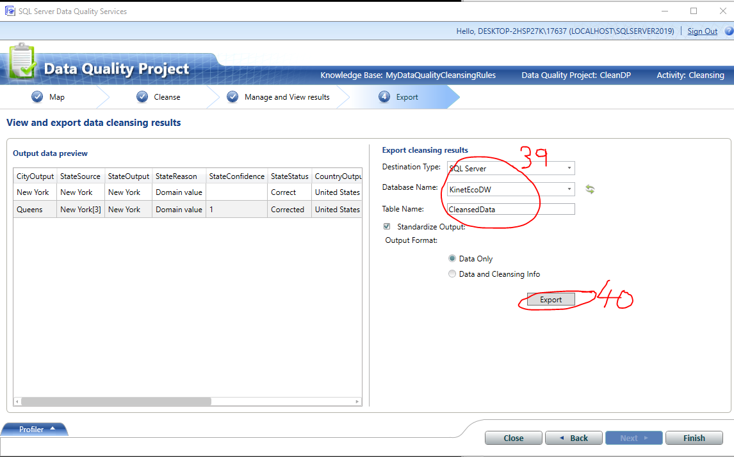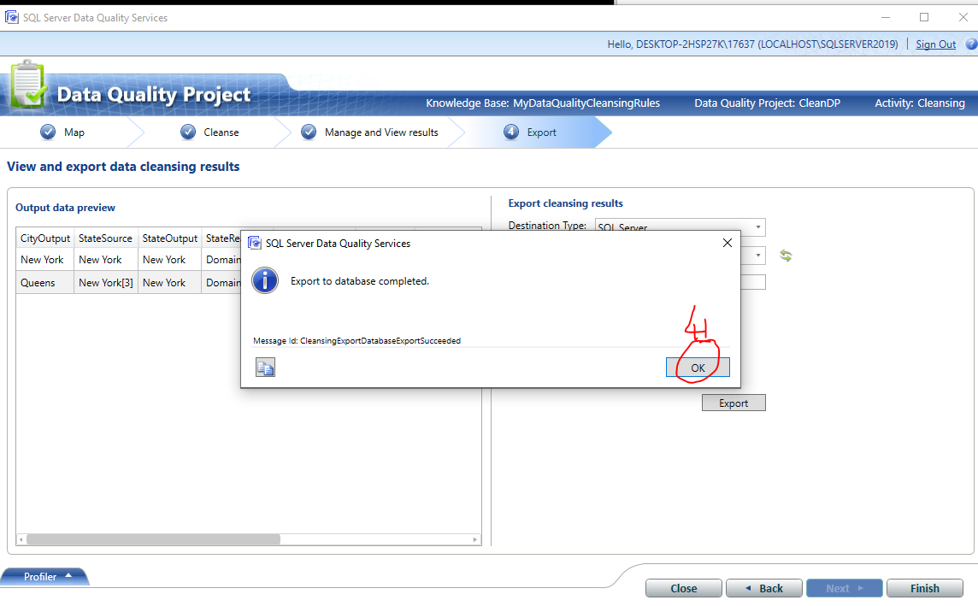

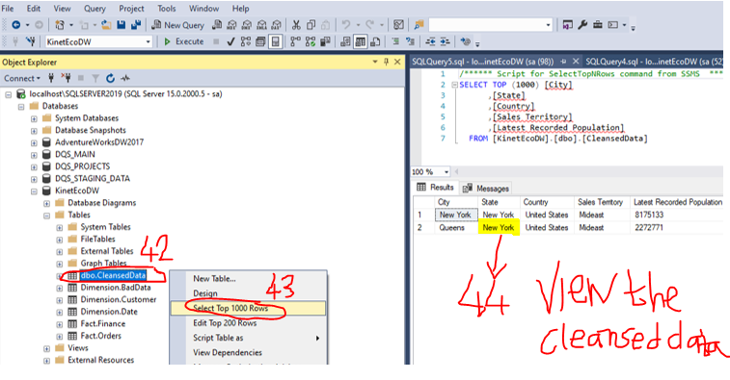

## 6.4 Chapter Quiz

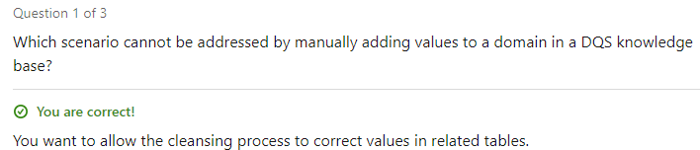

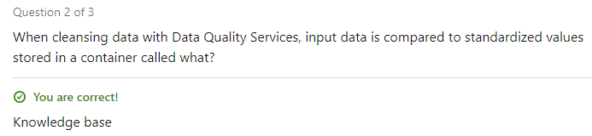

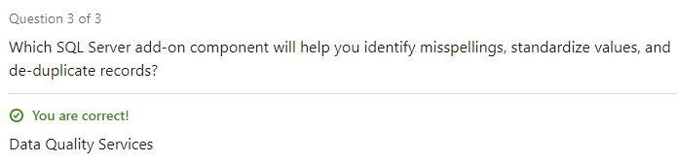

# 7.Master Data Services (Clean data before its loaded into data warehouse)

## 7.1 Installing the (Master Data Services) Plugin for the MSS GUI

Master Data Services = cleanses the data before its loaded into the Data Warehouse. Master Data Services is considered better than Data Quality Services because in DQS we only focused on cleansing the data after its loaded into the data warehouse.











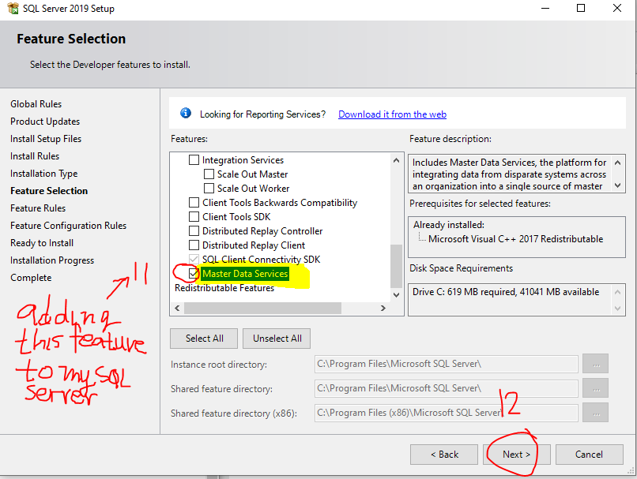

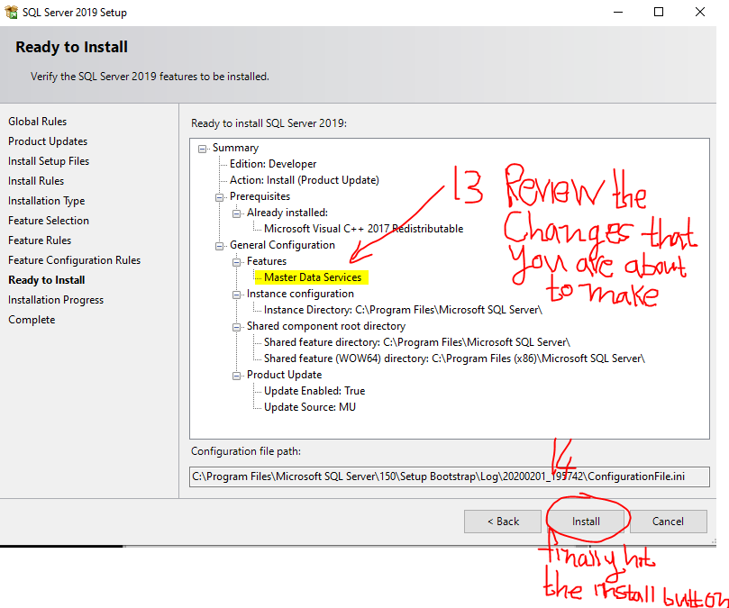

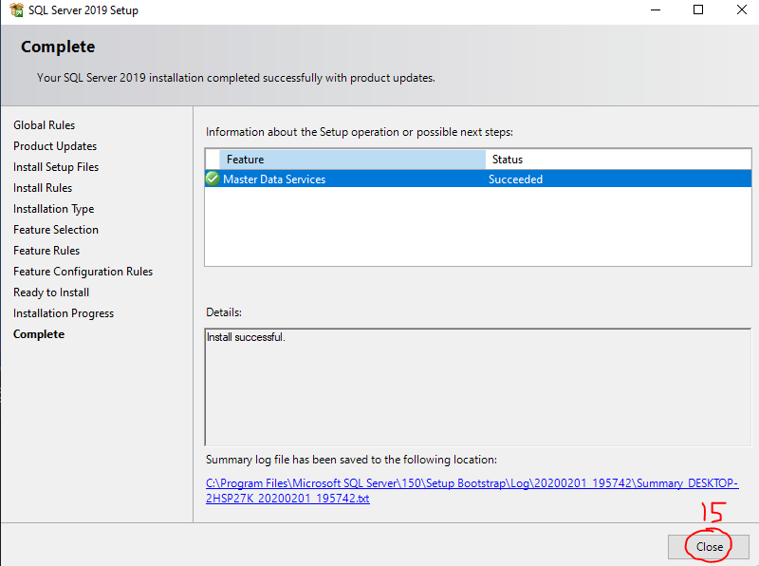



## 7.2 Installing IIS

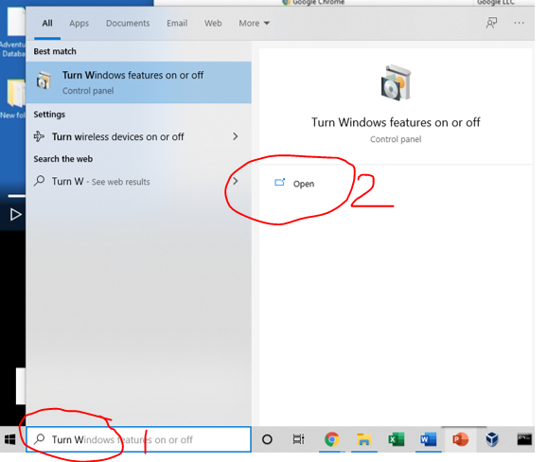

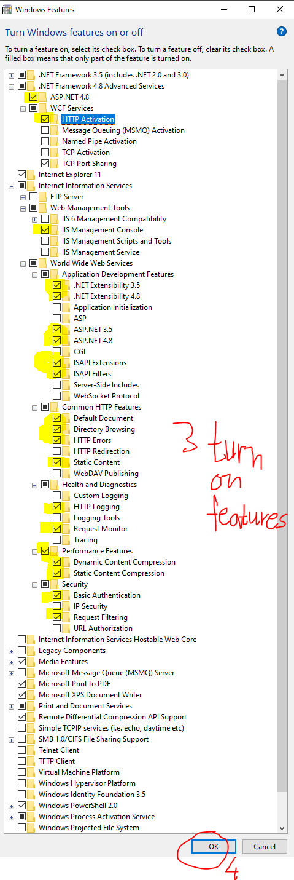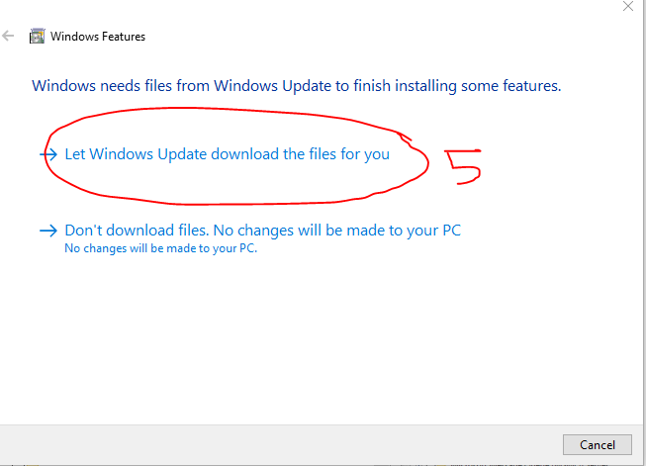

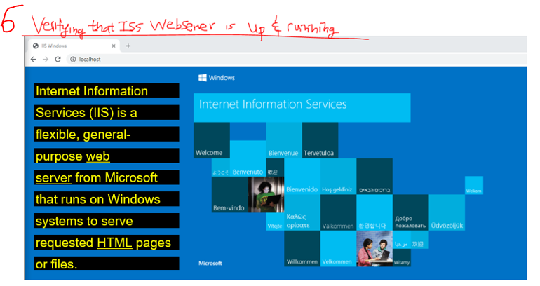

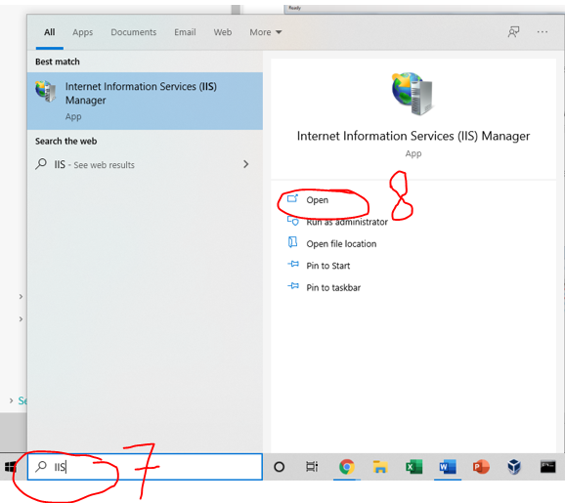

## 7.2 Configure (Master Data Services) Plugin for the MSS GUI

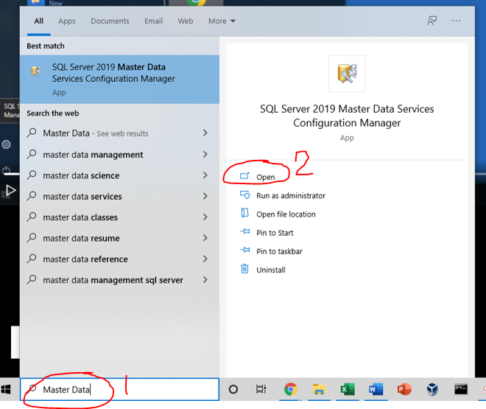

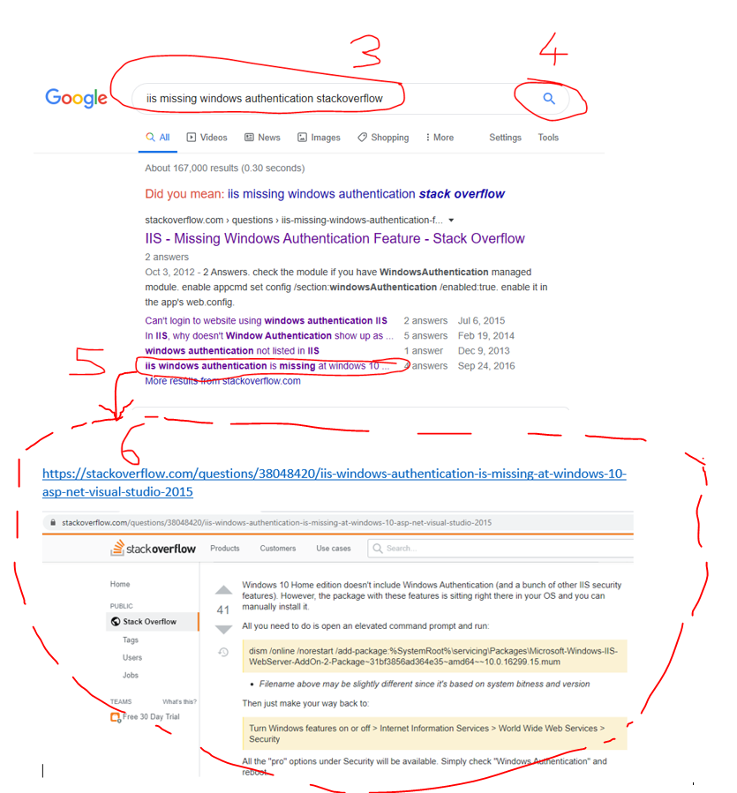

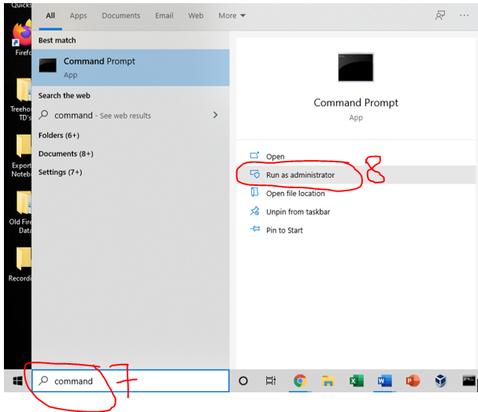

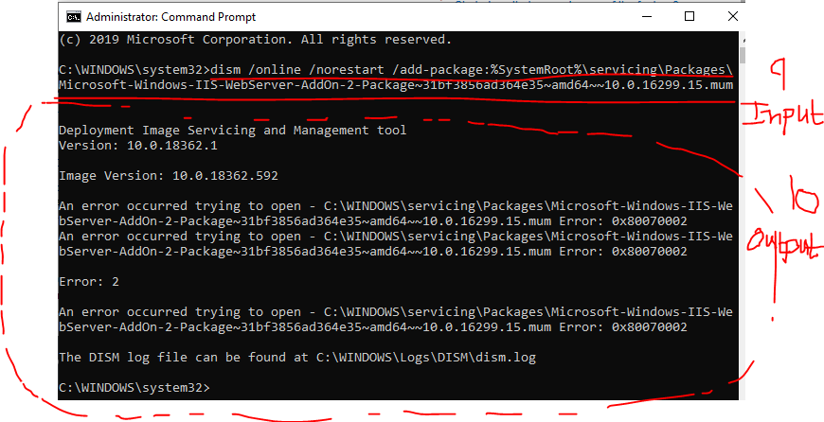

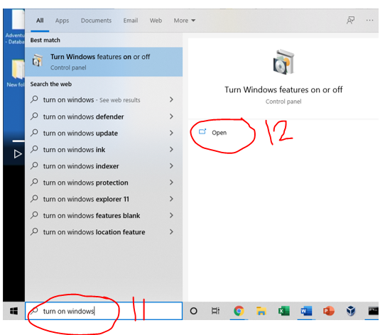

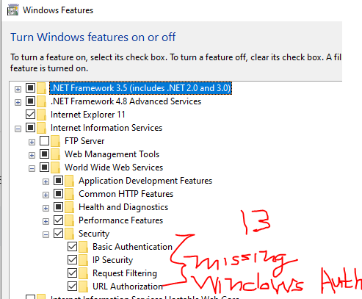

……. I guess I cant use the Master Data Services Tool because Windows 10 doesn’t have “Windows Authentication”. However, this doesn’t really matter I can clean the data before its loaded into the datawarehouse using Data Quality Tools or I can clean the data after its loaded into the datawarehouse using Master Data Services Tools. Since I able to successfully clean the data using the Data Quality Tools it doesn’t matter if I’m cleaning the data before or after its loaded into the data warehouse. All that matters is the fact I can use 1 out of the 2 tools to successfully clean the data and in my case I can use the Data Quality Tools to clean the data after its loaded into the datawarehouse so that means that not being able to use Master Data Services Tool has zero impact on my ability to clean the data.

## 7.3 Chapter Quiz

